**SimAgile Execution 2 Report - Team Based Response (60 Points)**

***Please use the following link to access SimAgile:*** [***http://agile.simproject.com/***](http://agile.simproject.com/)***. Complete a second execution from beginning to end and answer the questions that follow.***

***Important Note: if you receive an error while using SimAgile, please try rebooting your computer. If the problem isn’t fixed, please send an email to*** [***support@simulationpl.com***](mailto:support@simulationpl.com)***.***

**Sprint 1 - Week 1 and Week 2 (10 Points)**

**Product Backlog (one screen shot for sprint 1)**

* Paste a screen shot of your product backlog prior to starting sprint 1.

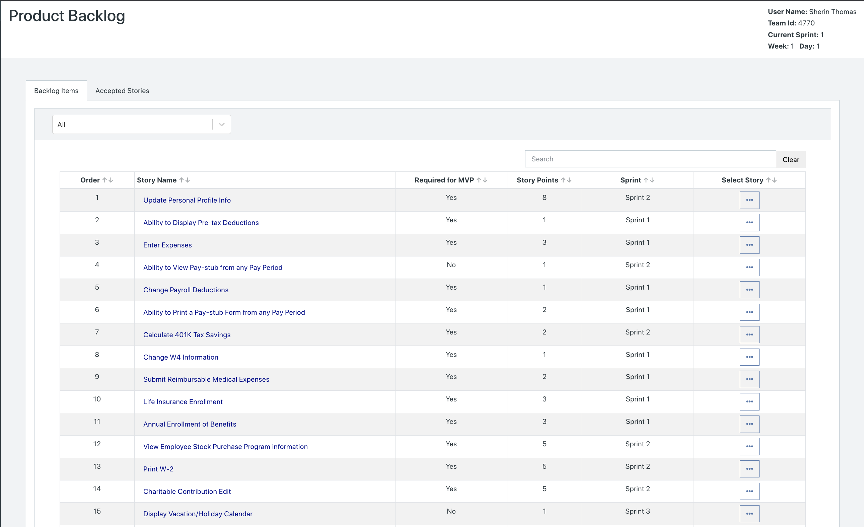

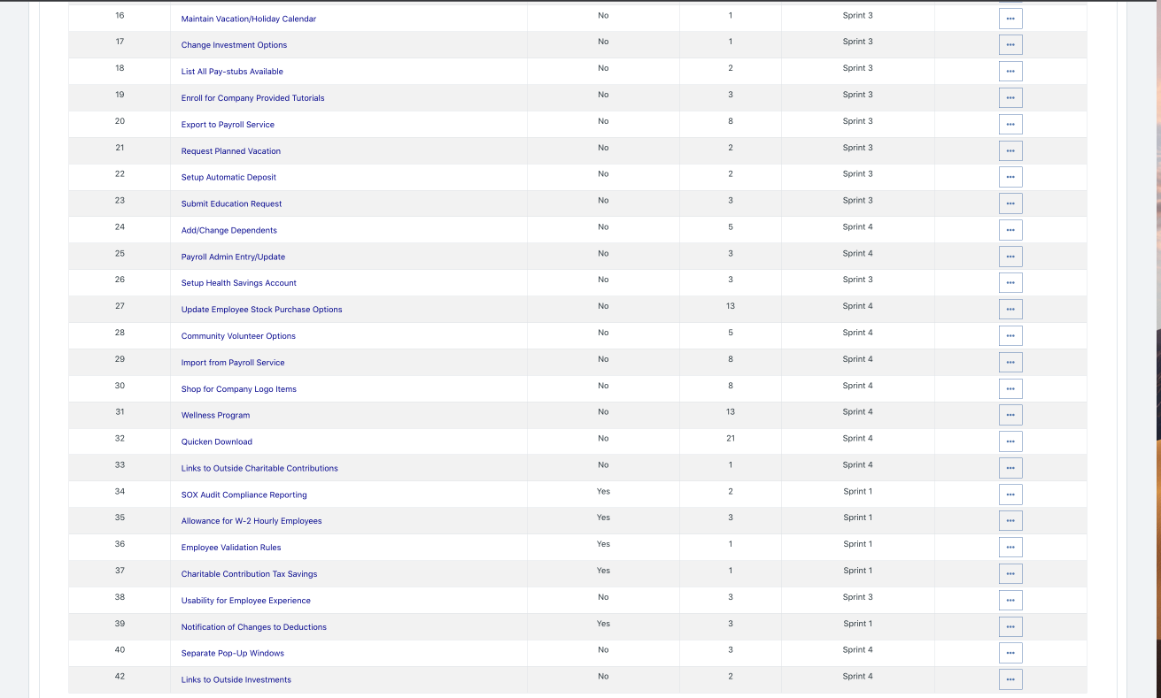

* Please explain what you did in grooming the user stories in your product backlog and your reasoning for these decisions. **Answer**
  + We started off with our product backlog by keeping it the same as the original release plan (same as Execution 1). We ensured that if there was anything past Sprint 4 in our release plan, we would incorporate it as part of Sprint 4 in the product backlog of the simulation as per instructions. Listed below are the methods we used in our release plan in grooming the backlog prior to running Sprint 1:
    - Sort user stories by MVPs (Z-->A)
      * We wanted to ensure that the MVP is delivered as soon as possible, and thus we wanted to focus on user stories pertaining to MVP first. Hence, using the Sort& Filter option in Excel, we placed all MVP user stories at the top.
    - Calculate Business Value per story point
      * We wanted to deliver the most amount business value per story. Hence, we calculated the business value per story point for each user story. (Formula: Total Business Value Point/ Total Story Points)
    - Sort user stories by descending order of Business Values per story point
      * We wanted to complete the user stories with the most amount of business value per user story point first. Using the Sort & Filter option in Excel, we added a second level to the sort, in which after the MVP is sorted, Excel orders the user stories by the most business value per story point at the top, and the lowest at the bottom.
    - Assigning less than 30 story points for the first two sprints
      * We noticed how the MVP is mostly completed in the first two sprints. However, we did not want to maximize velocity (30 story points) in the first two sprints since we do not want to overload the developers with user stories. Moreover, we wanted to provide a buffer in case there are any issues when developing the MVP user stories. Hence, to sprint 1 we assigned 27 user stories and to sprint 2 we assigned 29 user stories.
    - Maximize the velocity for Sprint 3
      * For sprints 3, we tried to maximize velocity by including as many sorted user stories as possible without exceeding the limit of 30 user story points.
    - Add Sprint 5 and Sprint 6 user stories as Sprint 4’s user stories for the purpose of running this simulation.

**Scrum Board**

Scrum Board screen shot before sprint 1 has started

**Answer**

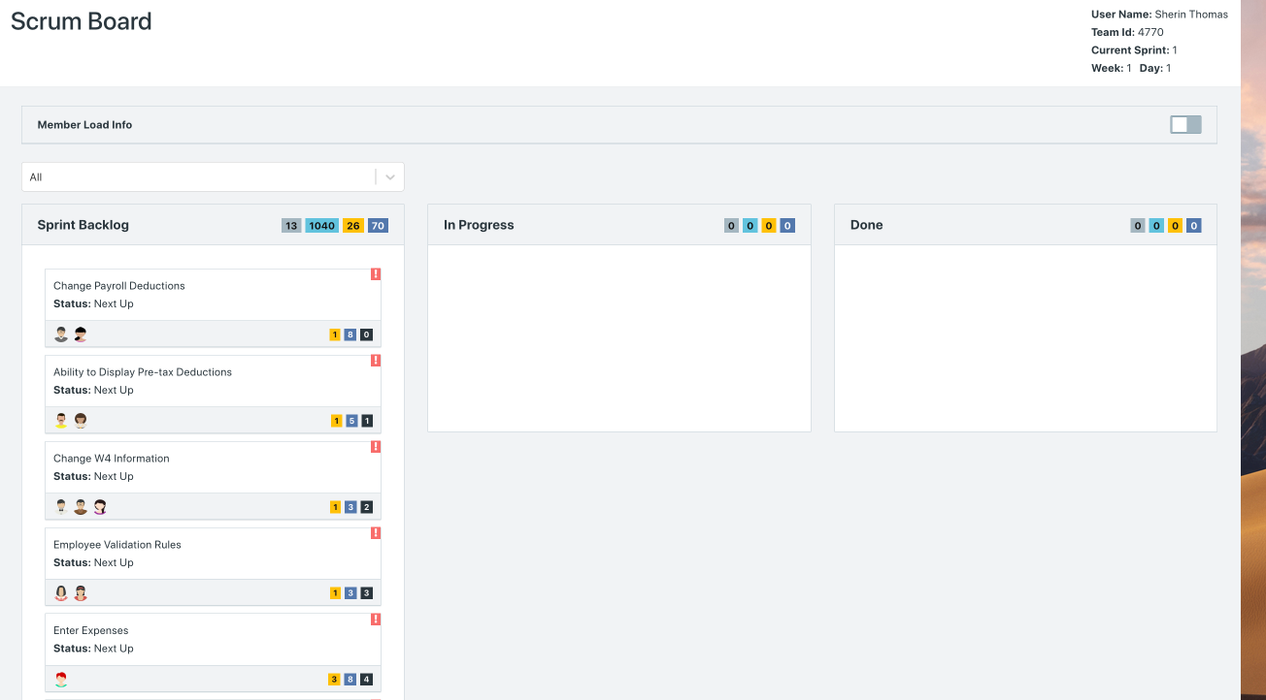

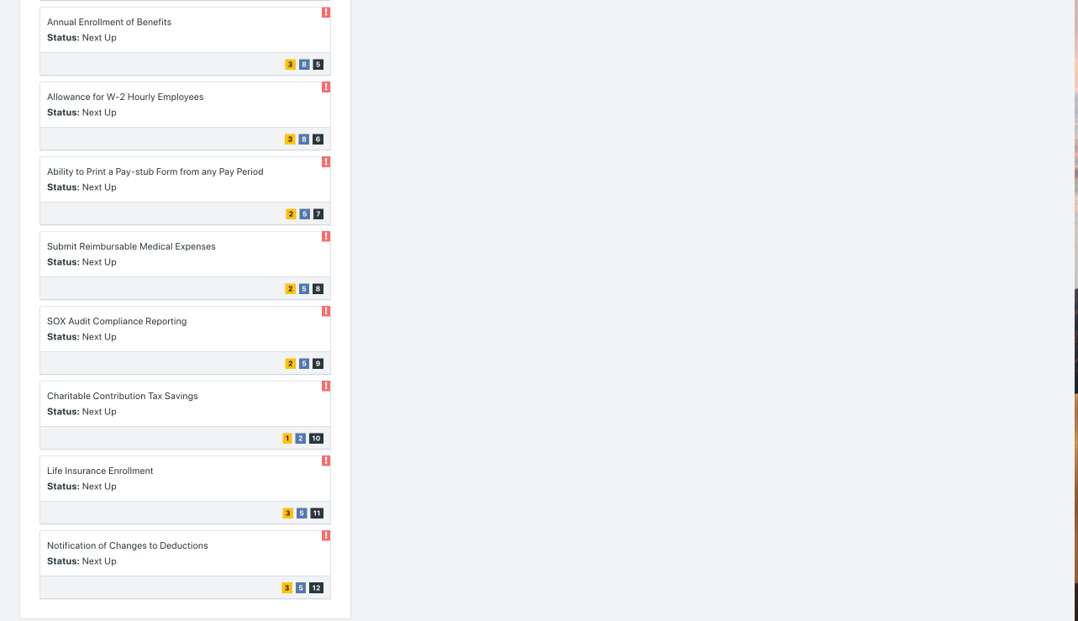

Scrum Board screen shot after 1st week of sprint 1

**Answer**

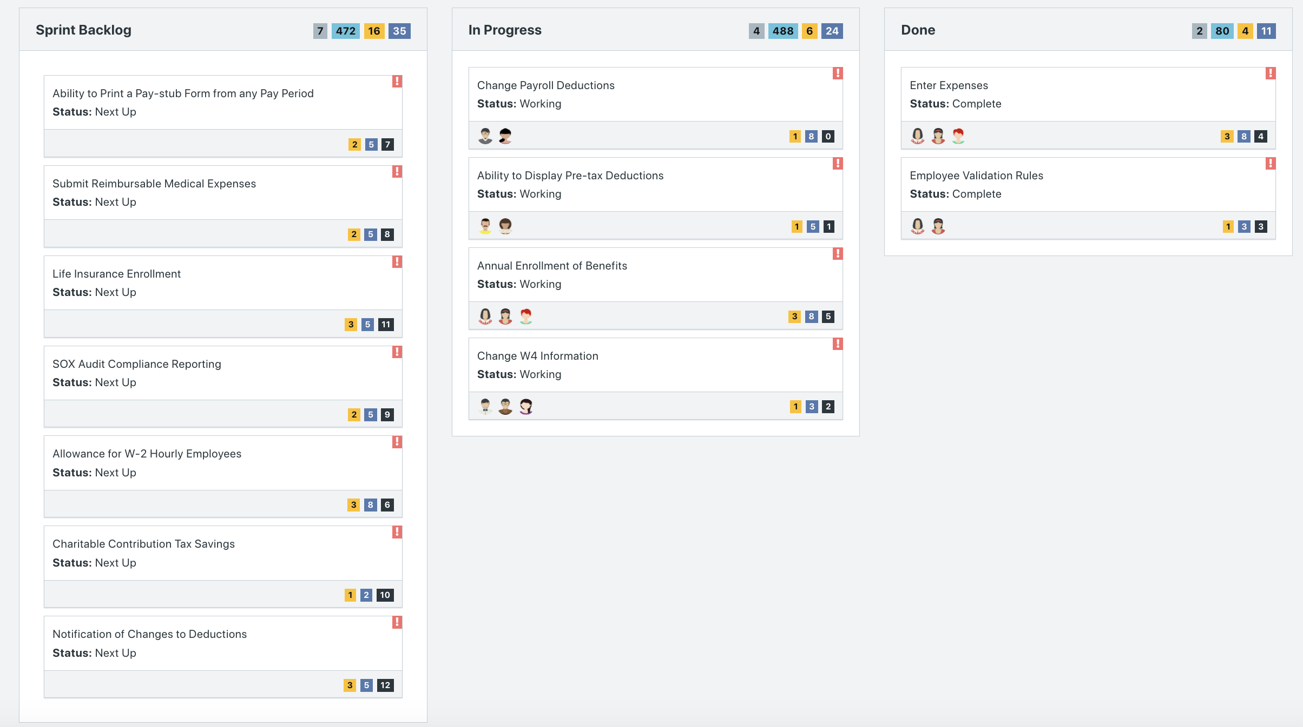

Scrum Board screen shot after 2nd week of sprint 1

**Answer**

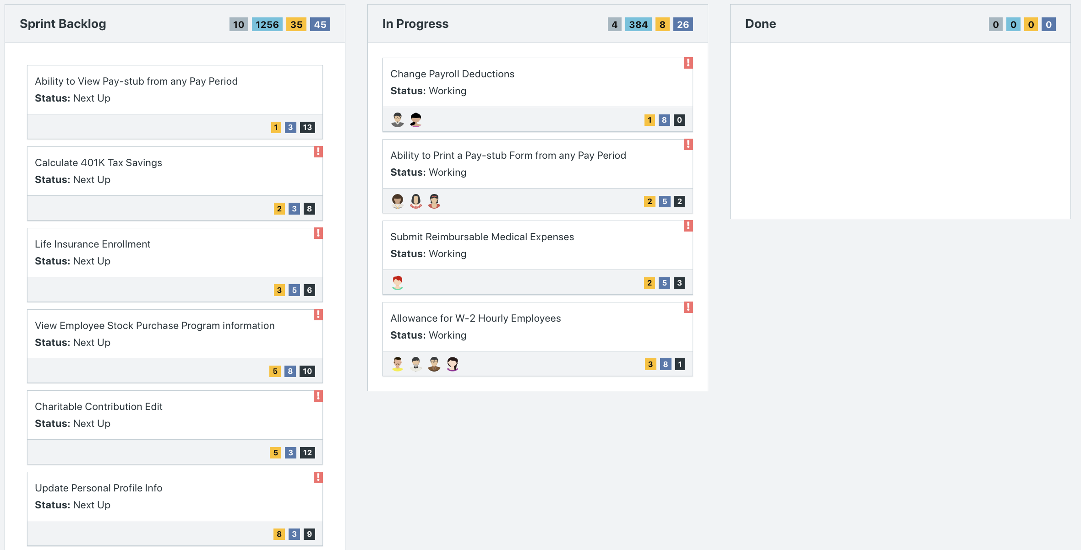

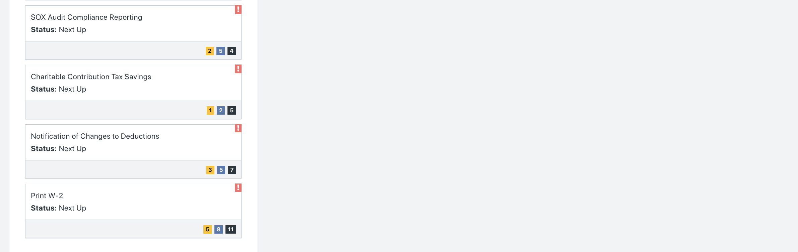

**Calendar**

Paste a screen shot of your calendar for sprint 1

**Answer**

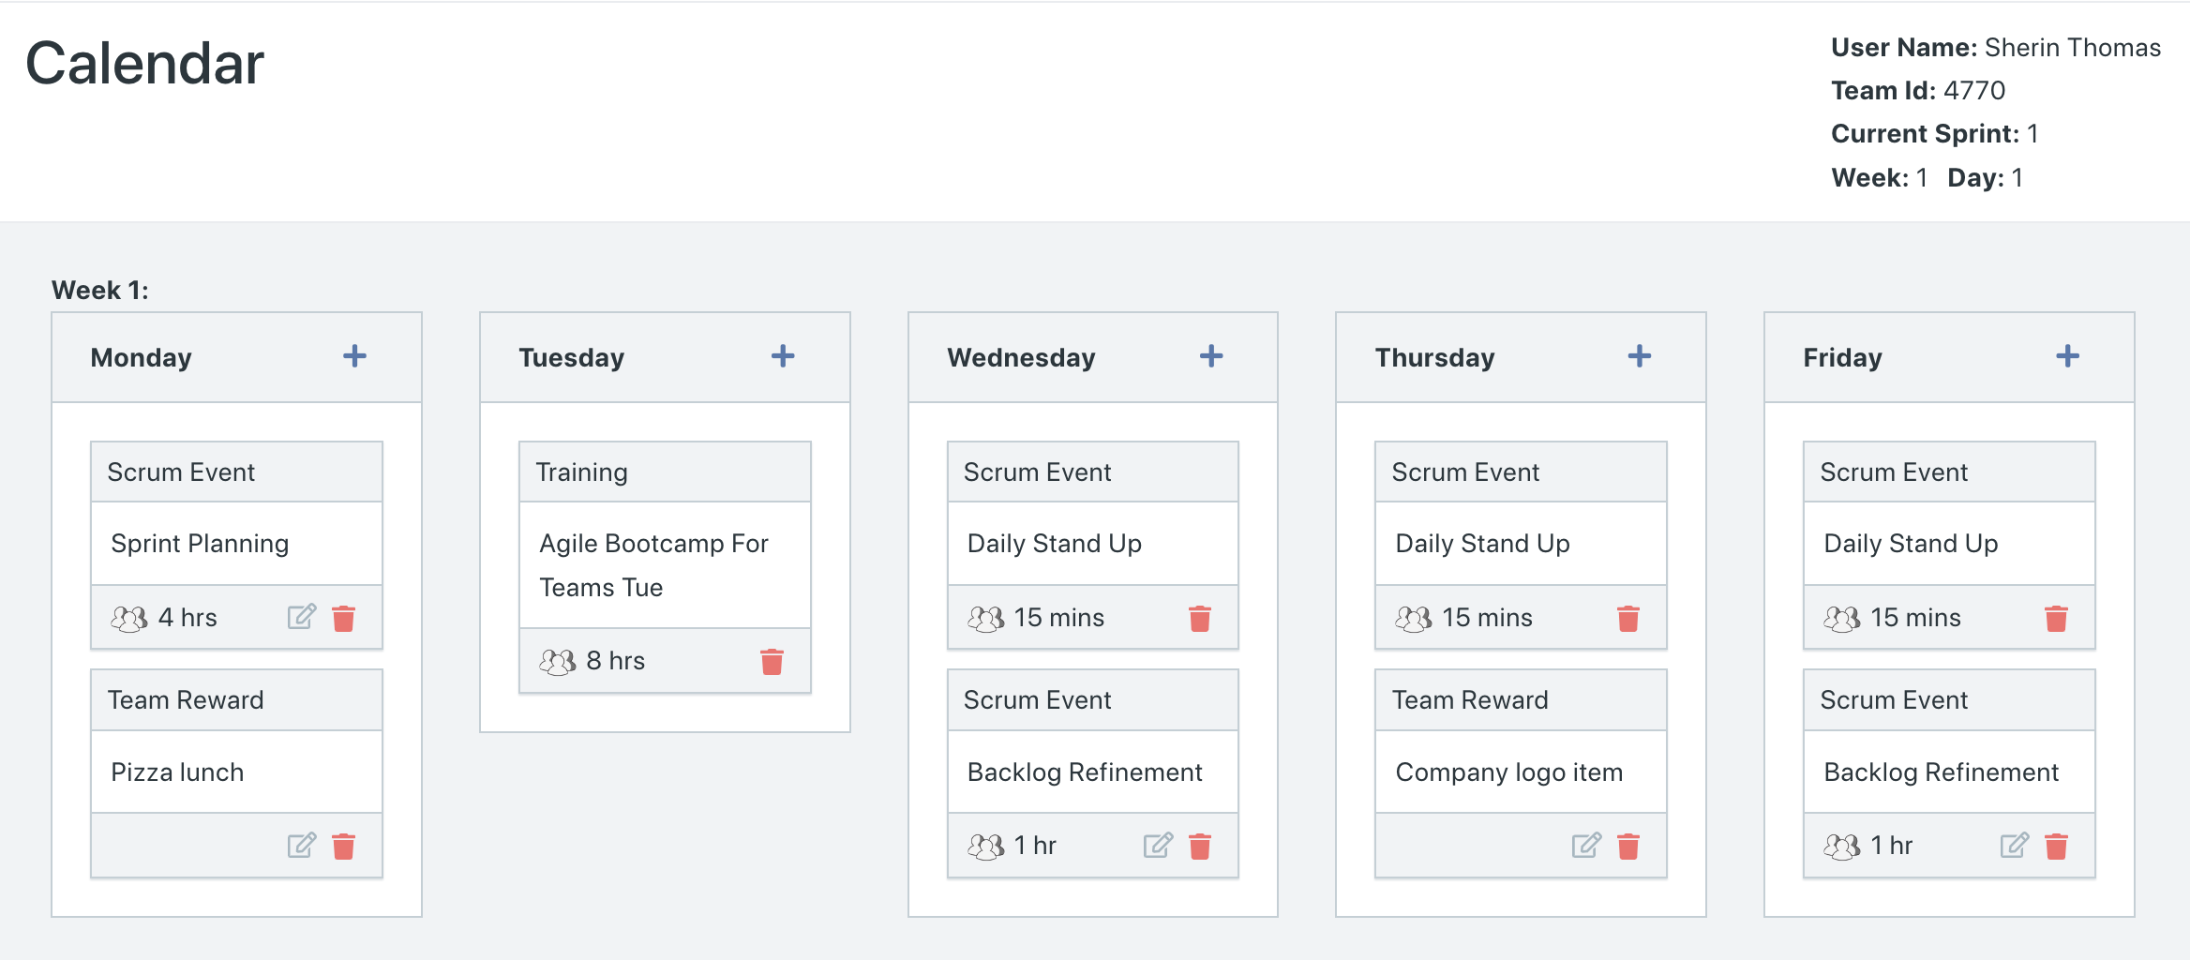

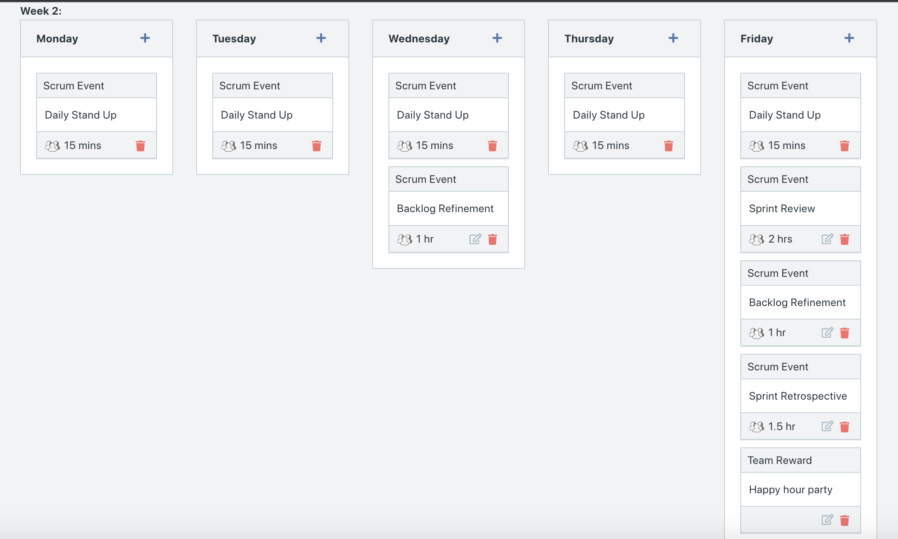

**After running Week 1:**

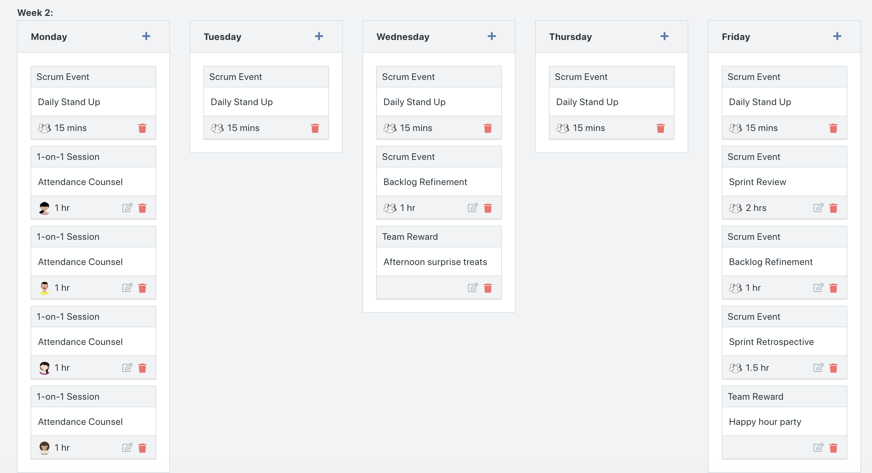

Explain the reason why you have scheduled the meetings listed shown on your calendar.

**Answer**

* **Necessary Scrum activities first:**
  + We put sprint planning on the first Monday of the sprint since we want to ensure that we plan our sprint before we even start, providing direction of the objectives of the sprint.
  + Daily Stands We added Daily Stand Ups every day after the Sprint Planning. This is to ensure that the team makes time to review what they have completed, what is going to be completed, and the impediments they are facing. Daily Stand Ups are crucial to the agile process.
  + We added Sprint Review followed by the Backlog Refinement and Sprint Retrospective on the last Friday of the sprint, since we want to review both the completed work and the scrum process at the end of each sprint to make necessary changes before proceeding to the next sprint.
* Other additions:
  + Based on last week’s execution learning curve, we decided that for this week’s execution we will provide an Agile Bootcamp on the first week. We did this because during last week’s execution we noticed how there were complaints about the Daily Stand Up and high absences for scrum activities. To combat the issue, we wanted to ensure everyone went to training to gain foundational knowledge about Agile.
  + Although backlog refinement usually occurs after Sprint Review, we added it to Wednesday to see if any changes were possible, such as assigning available team members to user stories that are currently in progress. This addition was attempted to increase efficiency of delivered/completed user stories.
  + We added a pizza lunch on the very first Monday since all team members are getting to know each other, and we hope the pizza lunch will provide an environment of casual conversation and getting to know one another.
  + We added a company logo items on the Thursday of the first week to have developers feel more unified working on the same team, under the same company.
  + We also added a Happy Hour Party at the end of Week 2 to celebrate the completion of the team’s very first sprint.
* Additions after running week 1
  + We took a record of the people who were absent and how many times they were absent for scrum activities after week 1 was run. Based on the record, we assigned 1-on-1 Sessions to counsel these individuals on their attendance.
  + We also added another team reward on Wednesday of week 2 to bring the team together more as they push through for the end of sprint 1.

**Burn Down**

After competing sprint 1, paste a screen shot of the sprint 1 Burn Down Chart below.

**Answer**

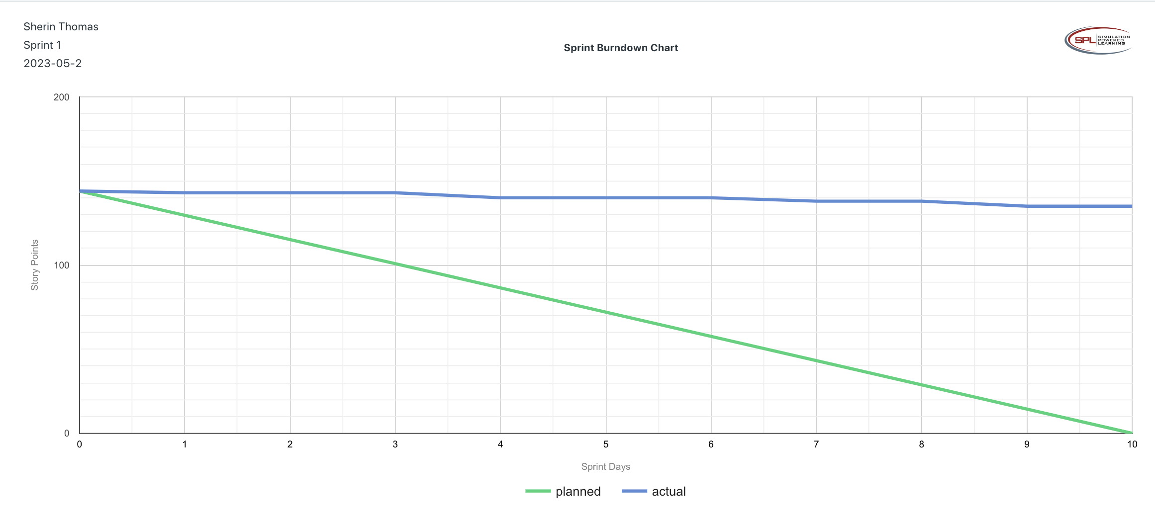

**Velocity Trend**

After competing sprint 1, paste the sprint 1 Velocity Chart below:

**Answer**

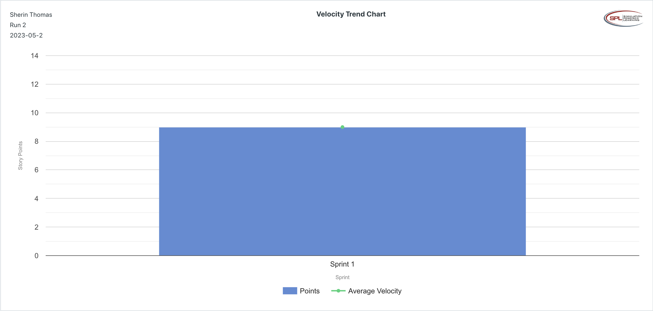

**Retrospective Meeting:**

How did you do in this Sprint?

**Answer**

* Out of the 26 story points planned for this Scrum, we completed only 9 story points, and the user stories worked on were all for MVP. Due to the very low velocity and not even meeting half of the expected velocity, we rate this Sprint a 1/5.

What problems, if any, did you encounter as you were executing the sprint?

**Answer**

* We had a lower velocity in this execution’s Sprint 1 compared to last week’s execution.
* When asked when we do user testing, we prompted more of a waterfall approach in which we do the UAT before the Release in the Hardening Sprint, but based on Agile we are supposed do acceptance occurs with each completed user story.
* We had a moment where we had a waterfall approach with the testing instead of following agile practices.
* We had multiple people skip scrum activities despite providing Agile Bootcamp training during the first week.

What changes, if any, are you are planning to make in the next sprint?

**Answer**

* We realized that when running a sprint, we can go back into the Scrum Board and continue to assign people who have available hours (based on the member workload chart) to user activities in progress. We are hoping this will increase the velocity.
* In addition to penalizing those who miss scrum activities, we want to reward those who are attending scrum activities. We hope this makes it clear what the expecations are.

**Answer following questions based on this Sprint:**

What is the velocity (in story points) for the sprint?

**Answer**

* 9 story points

What is the average velocity, minimum velocity, and maximum velocity (in story points) for the project across all sprints that have been completed so far?

**Answer**

* Because this is Sprint 1, we do not have data from other sprints to calculate total average, minimum, and maximum velocity.

Based on the current status of your project, do you believe that you will be able to complete the mandatory (or required) stories in the product backlog within the four sprints?  Explain your answer.

**Answer**

* Due to how significantly low our velocity is, we do not believe we will be able to complete the required stories in the product backlog. Out of the 18 MVP user stories required, we have so far only completed 4 MVP user stories, which is a only 22% completed, and 78% user stories remaining within the next 3 sprints. If we move forward with the same velocity as Sprint 1, we will be further behind schedule. The only way to complete all the MVP user stories within the next four sprints is to increase our velocity.

**Currently no**

Based on the current status of your project, do you believe that you will be able to complete all stories in the product backlog within the four sprints planned? Explain your answer.

**Answer**

* Our developers have not been able to complete all the user stories necessary for Sprint 1, meaning we are currently behind schedule. Hence, based on the velocity of Sprint 1, we believe we will not be able to complete all stories in the PBI within four sprints.

**Sprint 2 - Week 3 and Week 4 (10 points)**

**Product Backlog (one screen shot for the sprint)**

Paste the screen shot of your Product Backlog below.

**Answer**

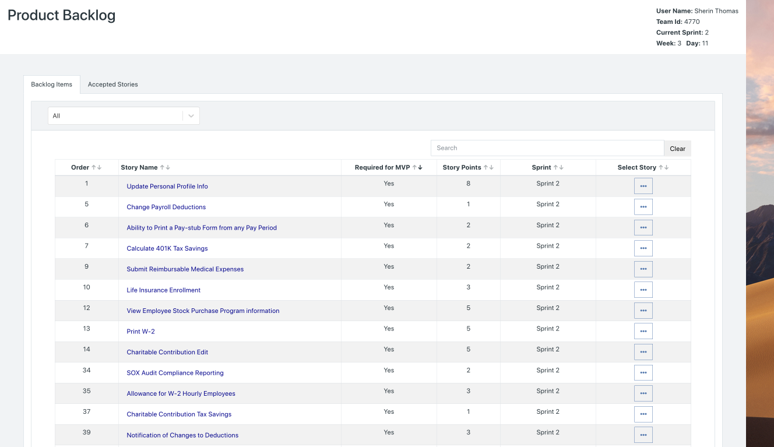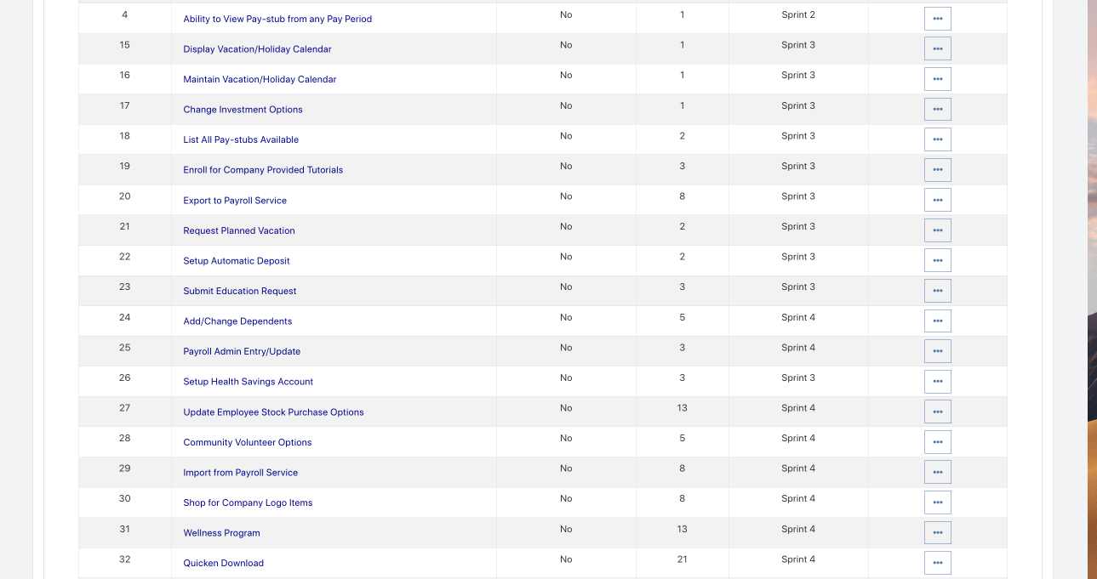

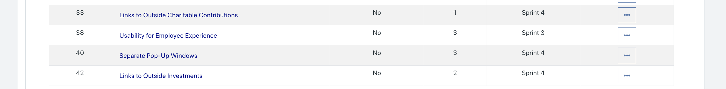

Please explain what you did in grooming the user stories in your Product Backlog and your reasoning for these decisions.

**Answer**

* While we kept the user stories originally planned for Sprint 2, 3, and 4 the same as Sprint 1, whatever Sprint 1 user stories that were remaining, we reassigned them to Sprint 2. Furthermore, in the Sprint Backlog we ensured that the remaining Sprint 1 user stories were given the highest priority and worked on before the user stories originally assigned to Sprint 2 user stories. We made this change to ensure that we are still delivering the MVPs with the highest business value per user story first. Since Sprint 1 user stories have higher business value per story point value than Sprint 2 user stories, we ensured the remaining Sprint 1 user stories in the backlog are completed first.

**Scrum Board**

Scrum Board screen shot before sprint 2 has started

**Answer**

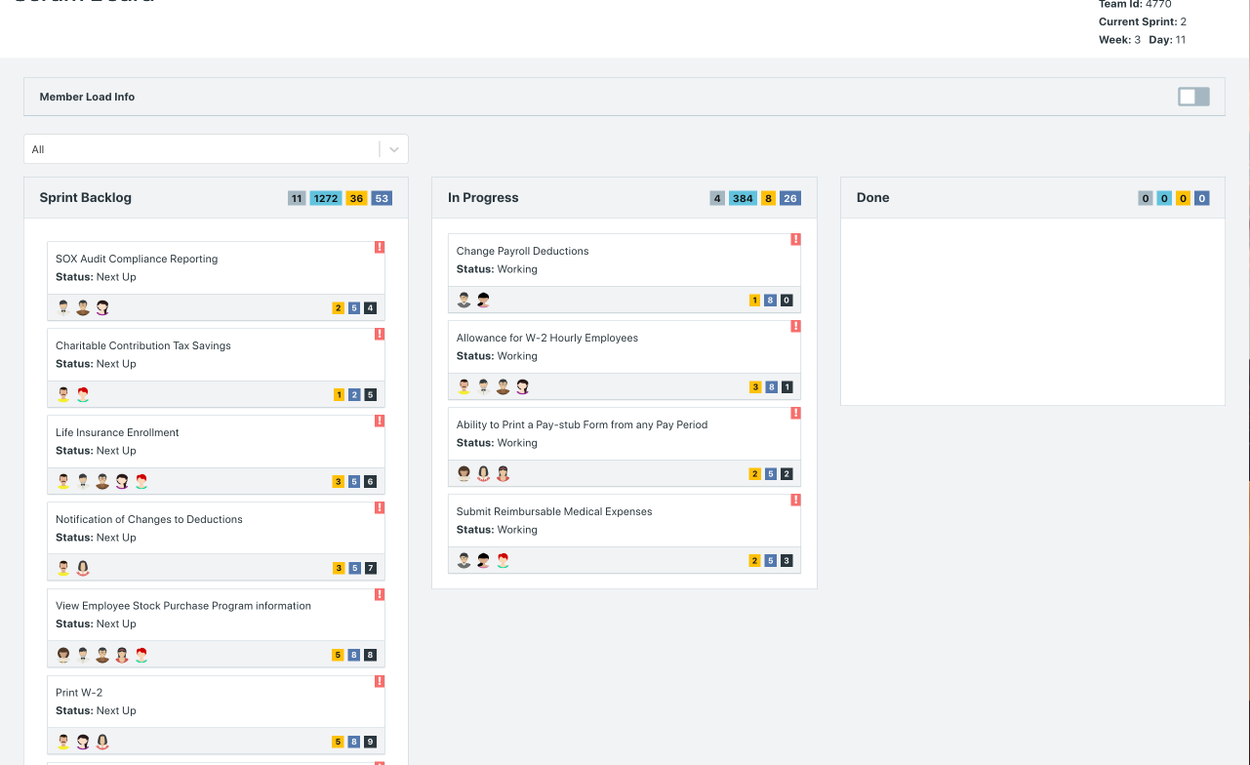

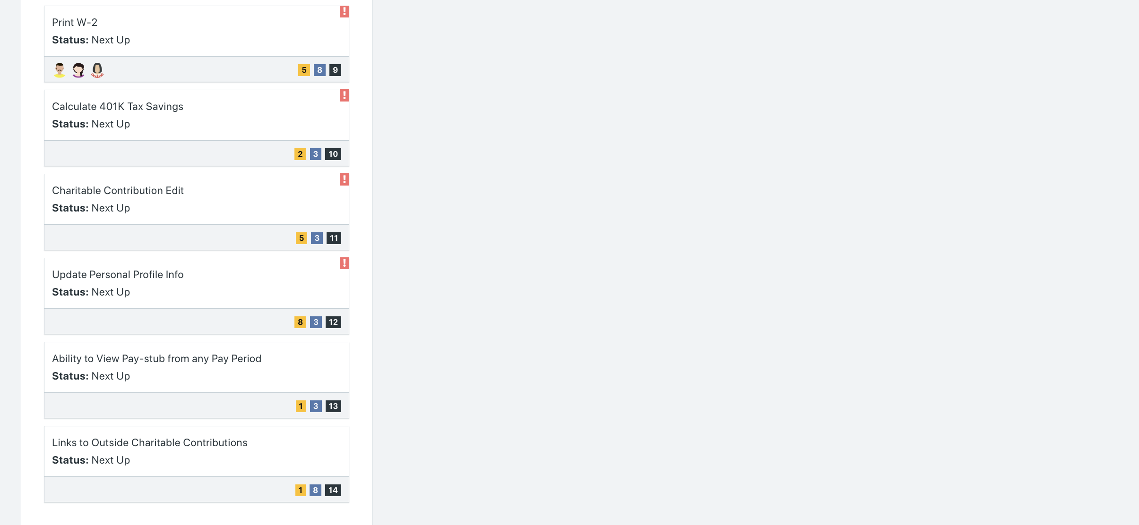

Scrum Board screen shot after 1st week of sprint 2

**Answer**

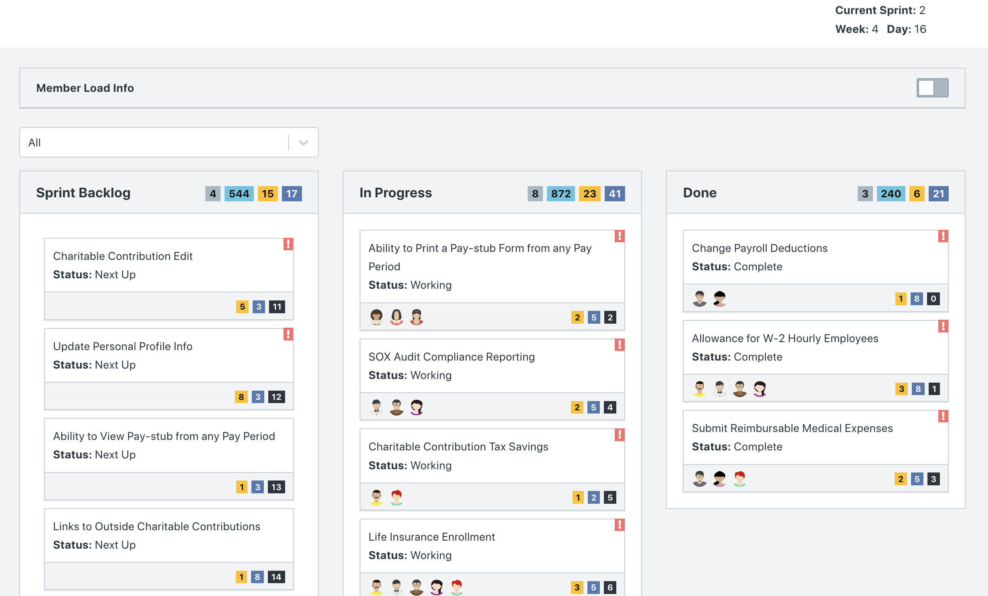

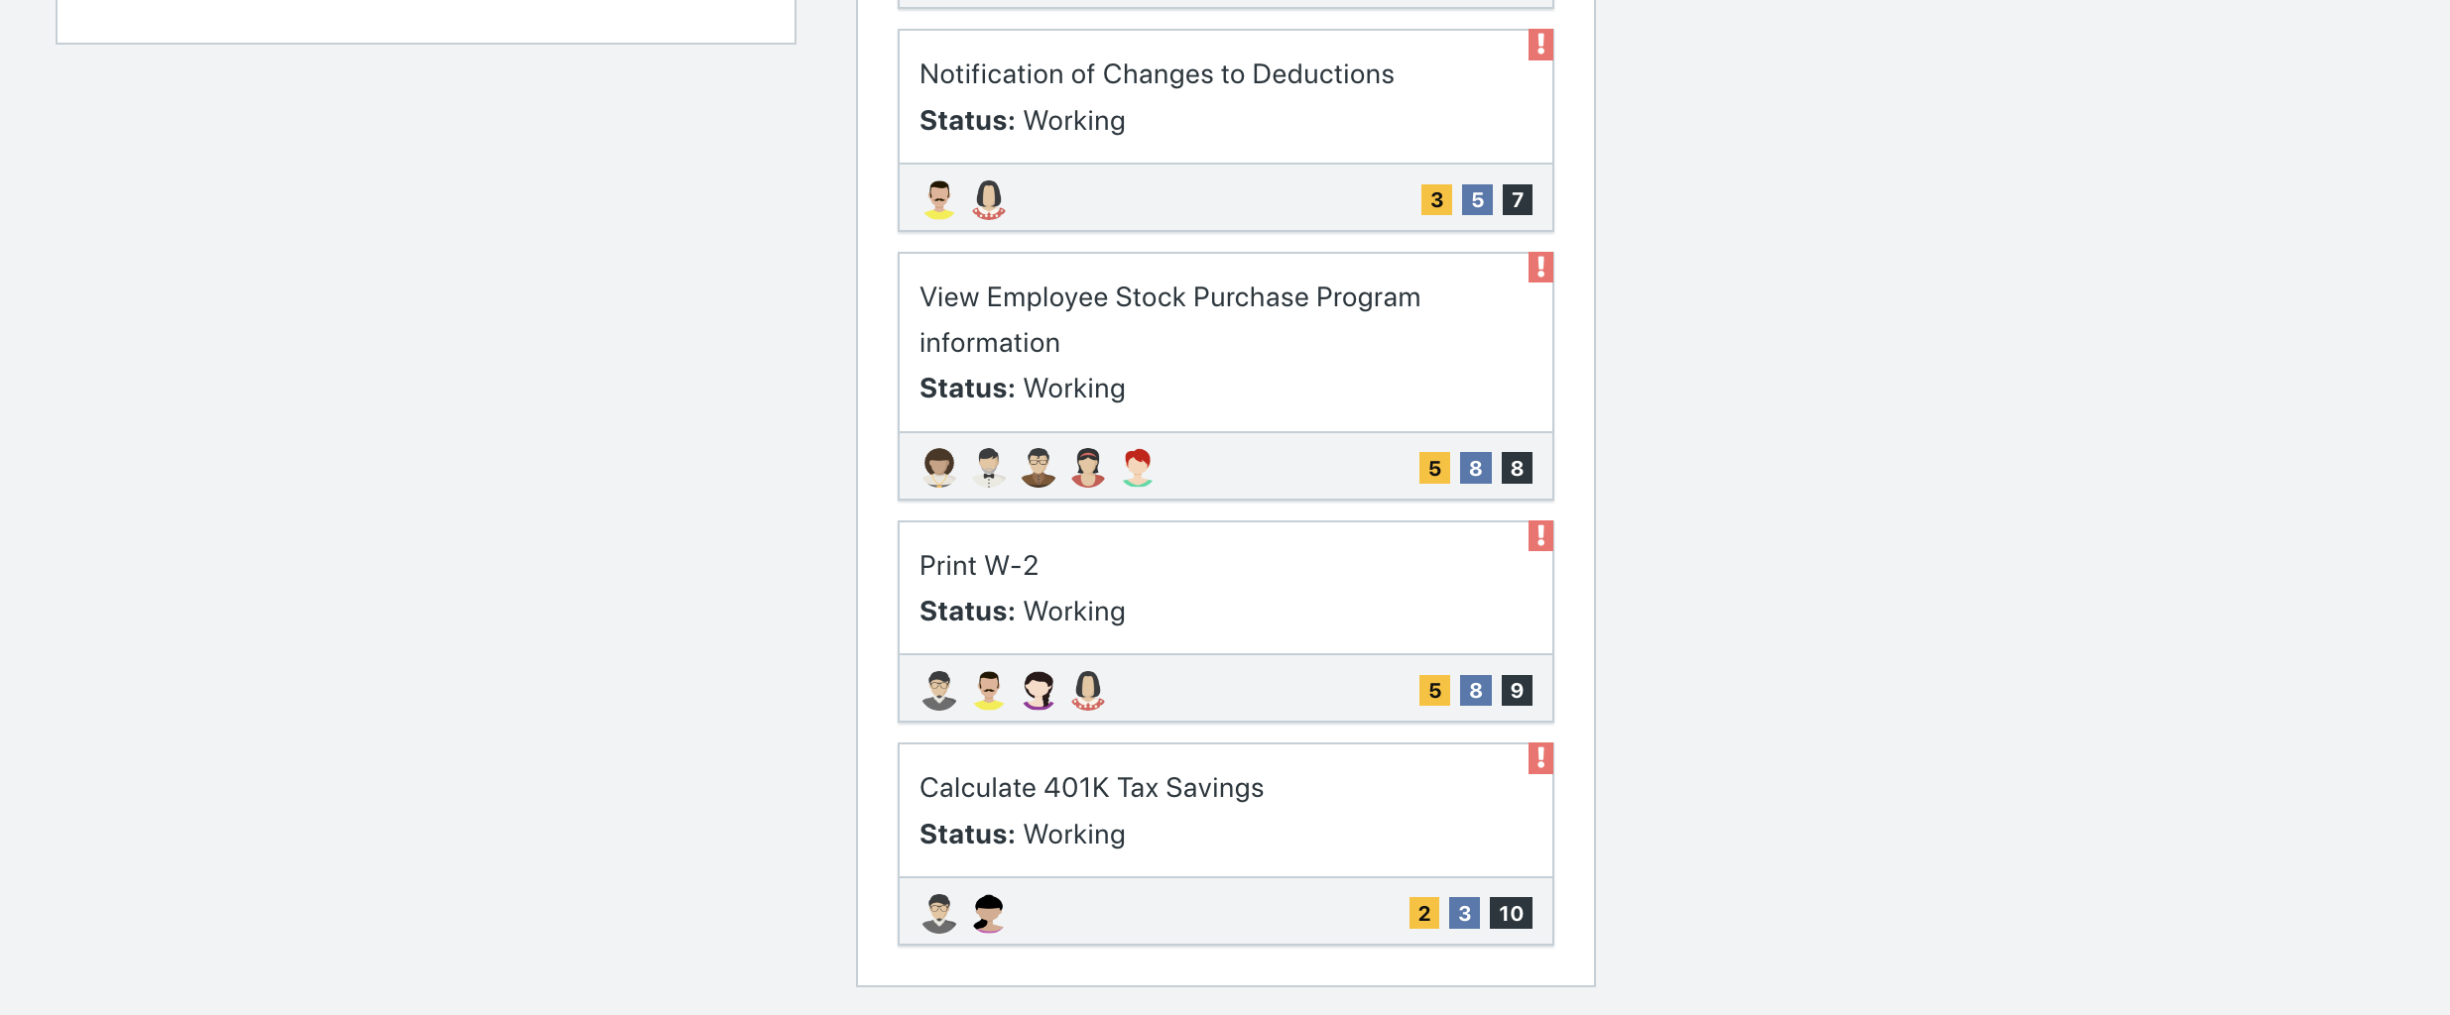

Scrum Board screen shot after 2nd week of sprint 2

**Answer**

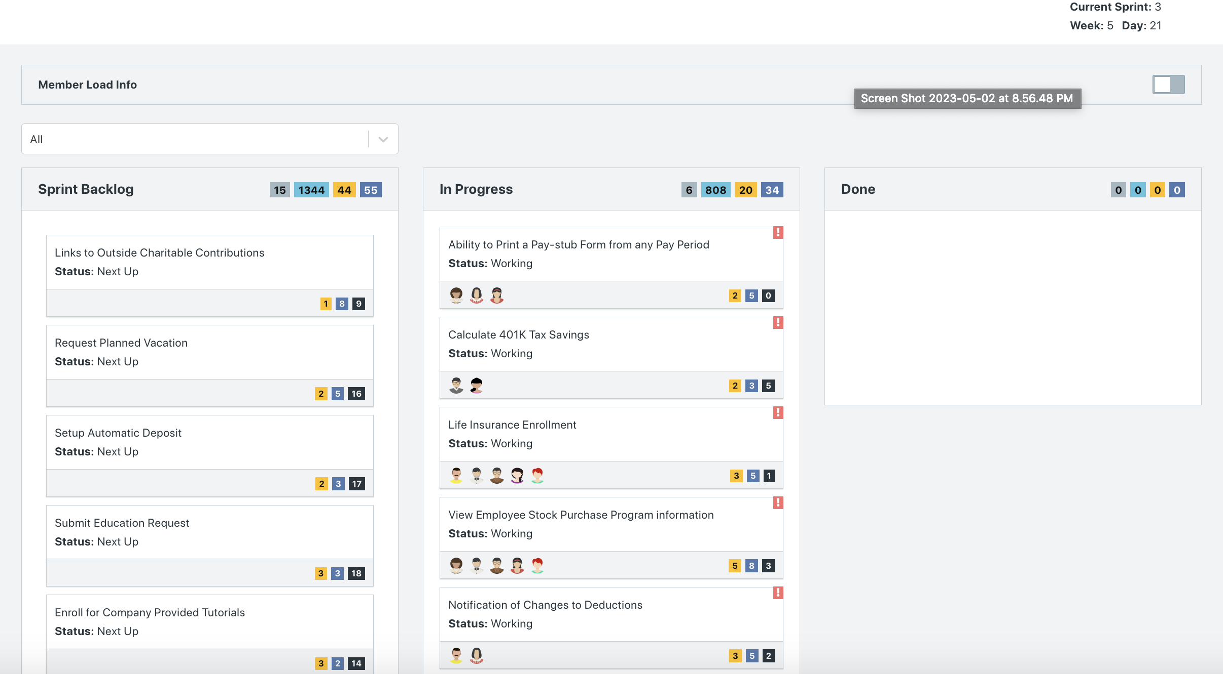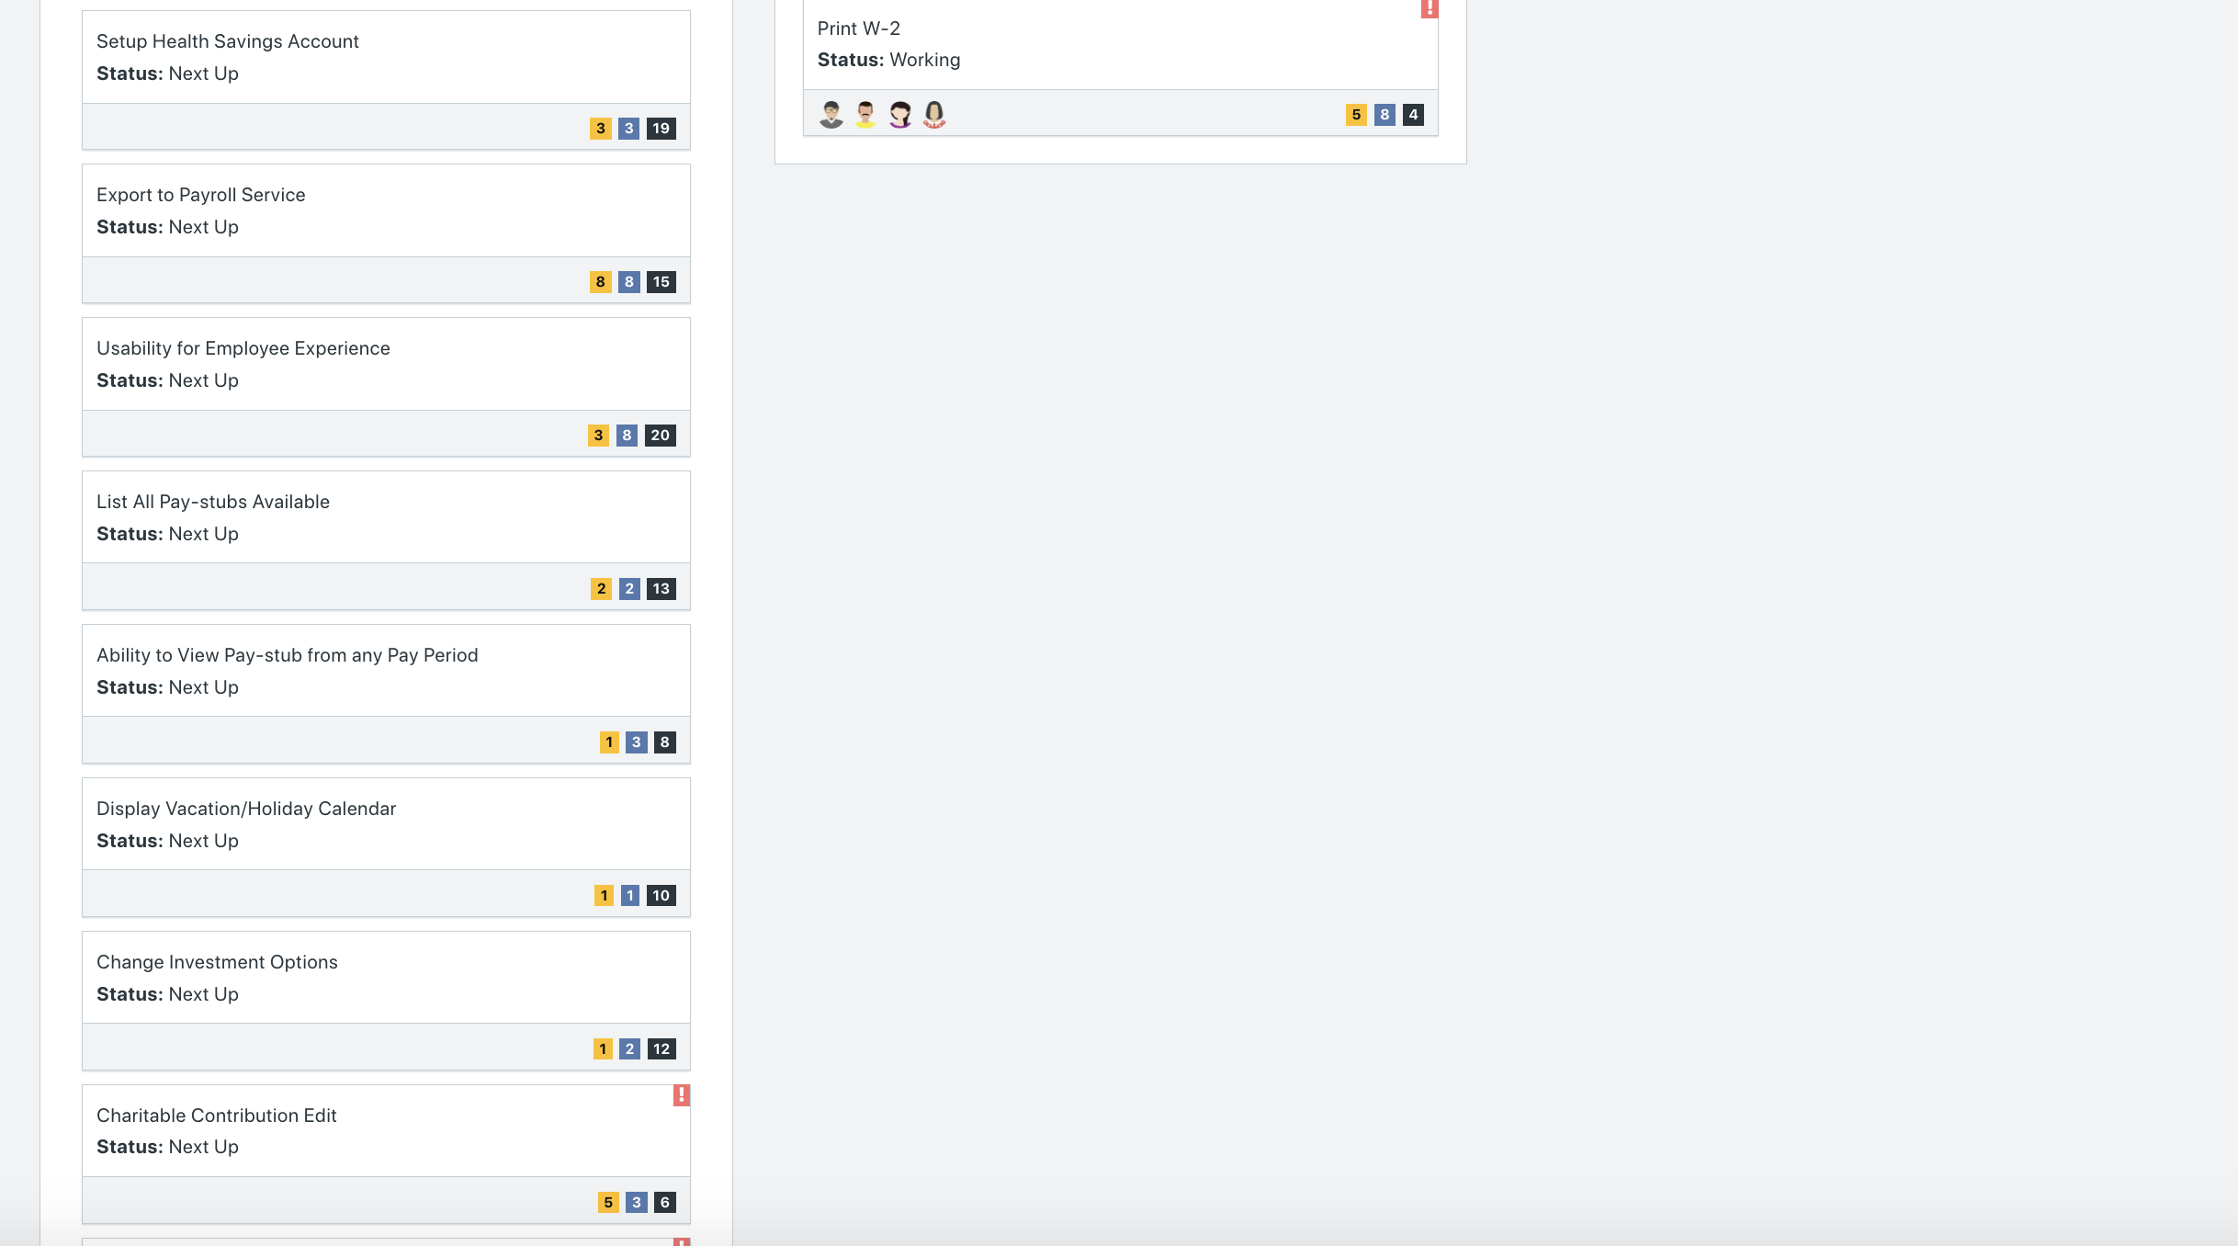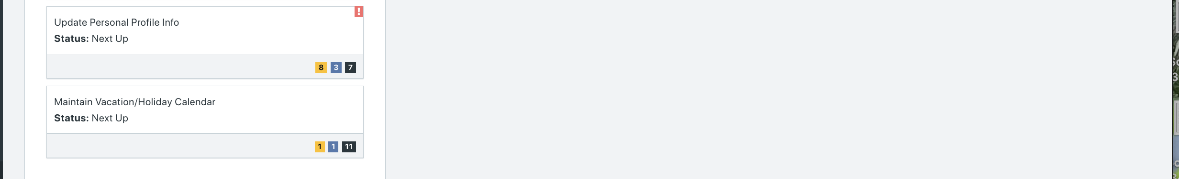

**Calendar**

Paste the screen shot of your calendar for sprint 2

**Answer**

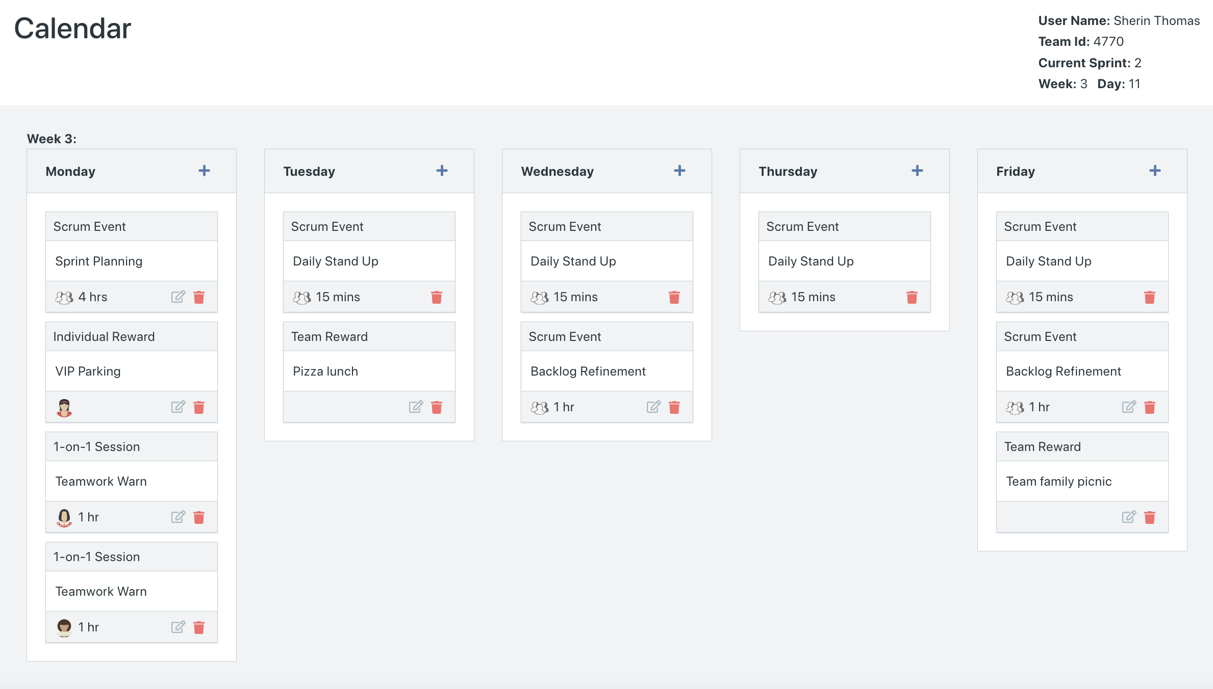

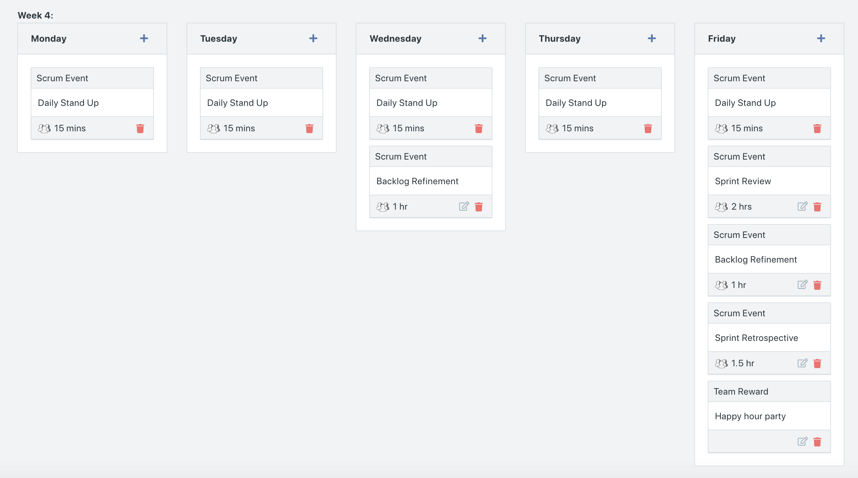

**After Week 3 Additions**

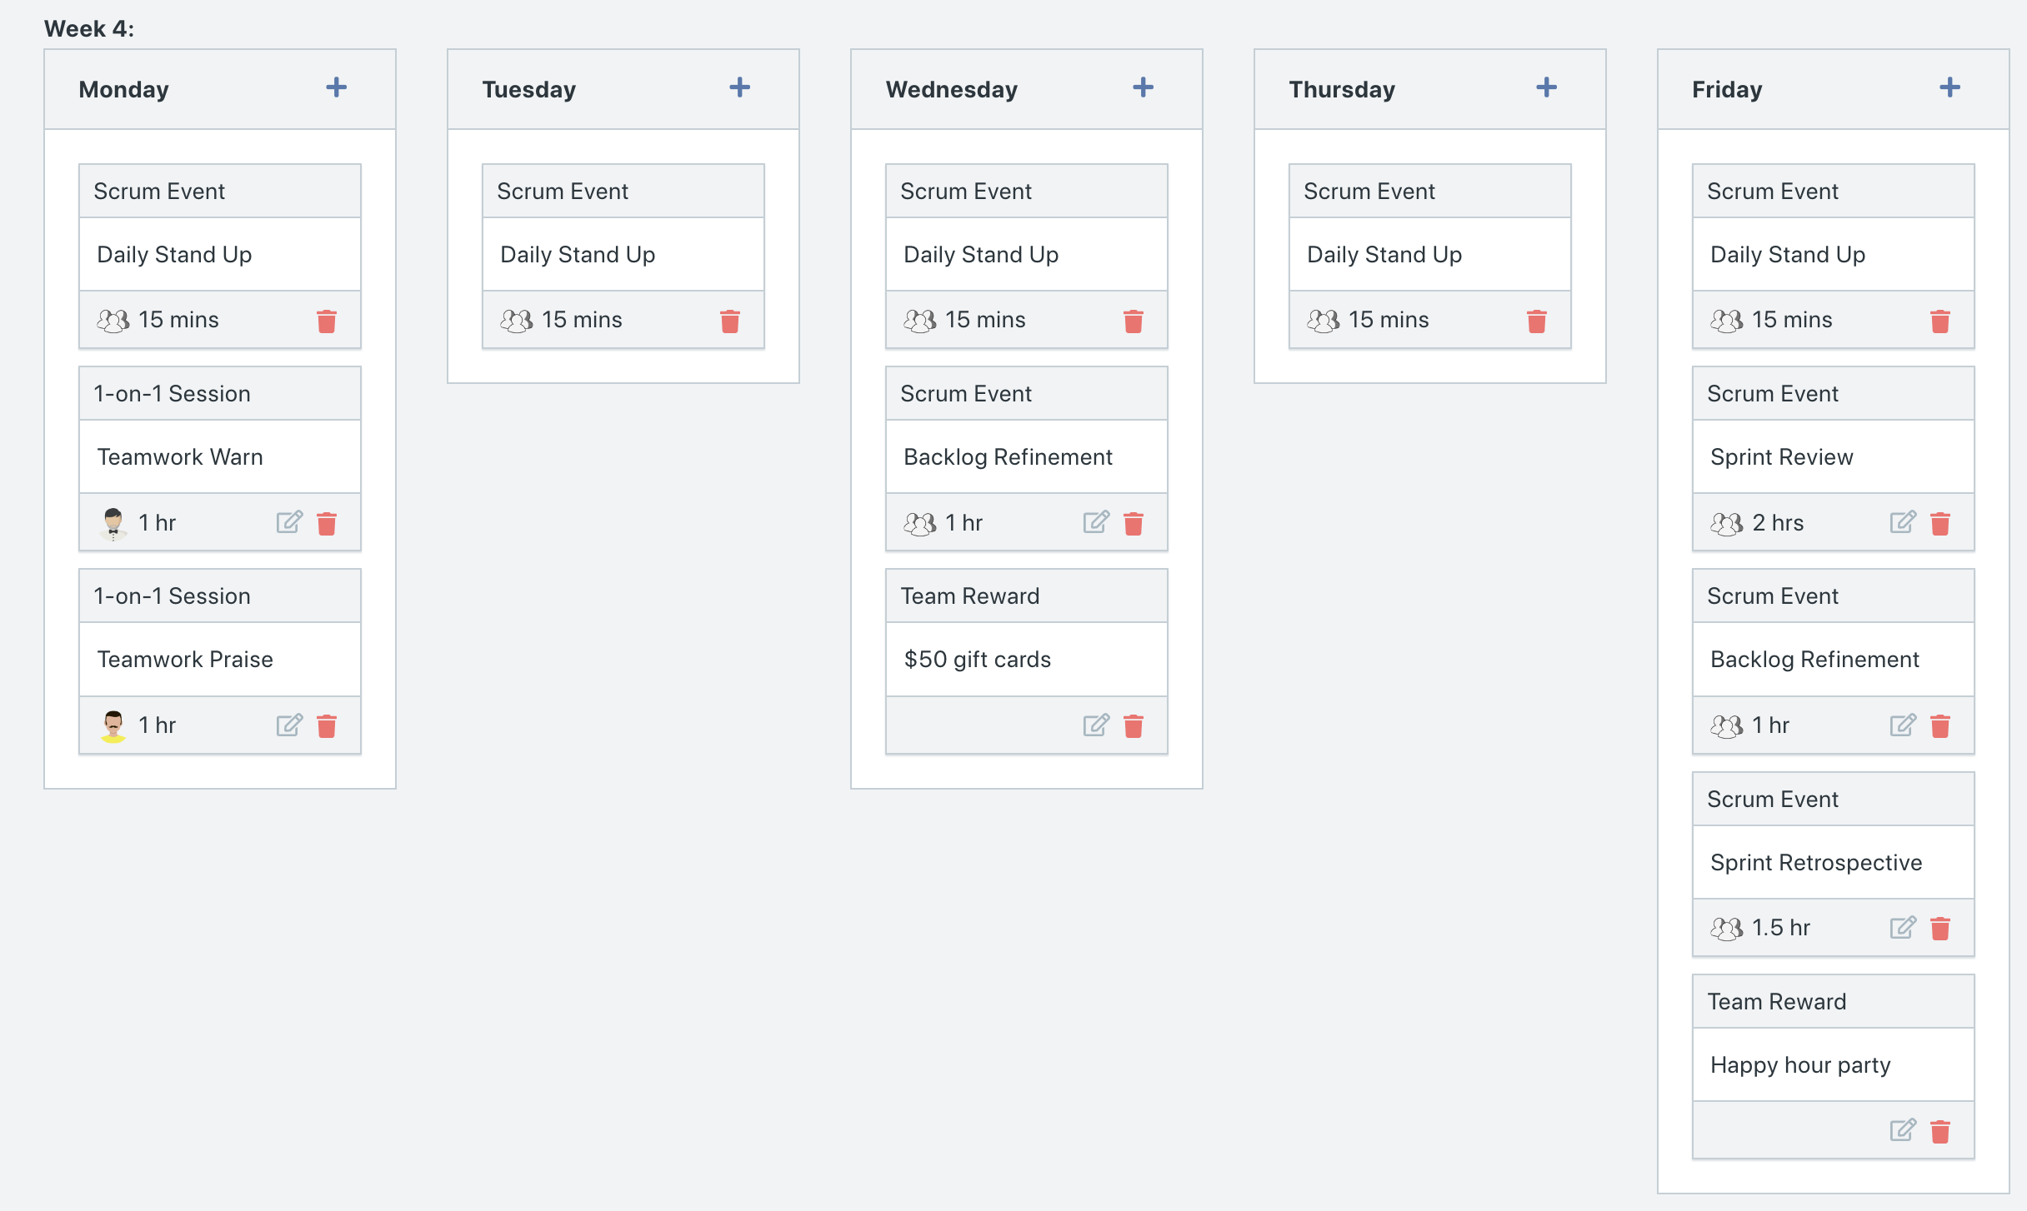

Explain the reason why you have scheduled the meetings listed shown on your calendar (if any)?

**Answer**

* On the first Monday of the week, we rewarded Maria with VIP Parking for not missing any scum activities during Sprint 1. This is to showcase that being part of the agile process is rewarded and favored upon.
* For those who were missing scrum activities, instead of giving them a 1-on-1 session for attendance, we decided to give them a 1-on-1 session for teamwork. The point of scrum activities is to keep the team accountable and work as a team to decide how to move forward, remove impediments, etc. Thus, by focusing on teamwork as the issue rather than attendance, we hope that will make a difference by improving developer’s participation in scrum activities.
* We added team rewards twice a week to continue bonding among team members and reward developers for their hard work.
* After Running Week 3
  + We added 1-on-1 sessions for team members who missed scrum activities during week 3. This is to remind them of the importance of participating in team scrum activities.
  + We added another two team rewards this week to continue rewarding developers for their hard work as they are approaching the end of the Sprint. We hope these rewards will encourage them to do their best and achieve better than last Sprint’s velocity.

**BurnDown**

After competing sprint 2, paste a screen shot of the sprint 2 Burn Down Chart below.

**Answer**

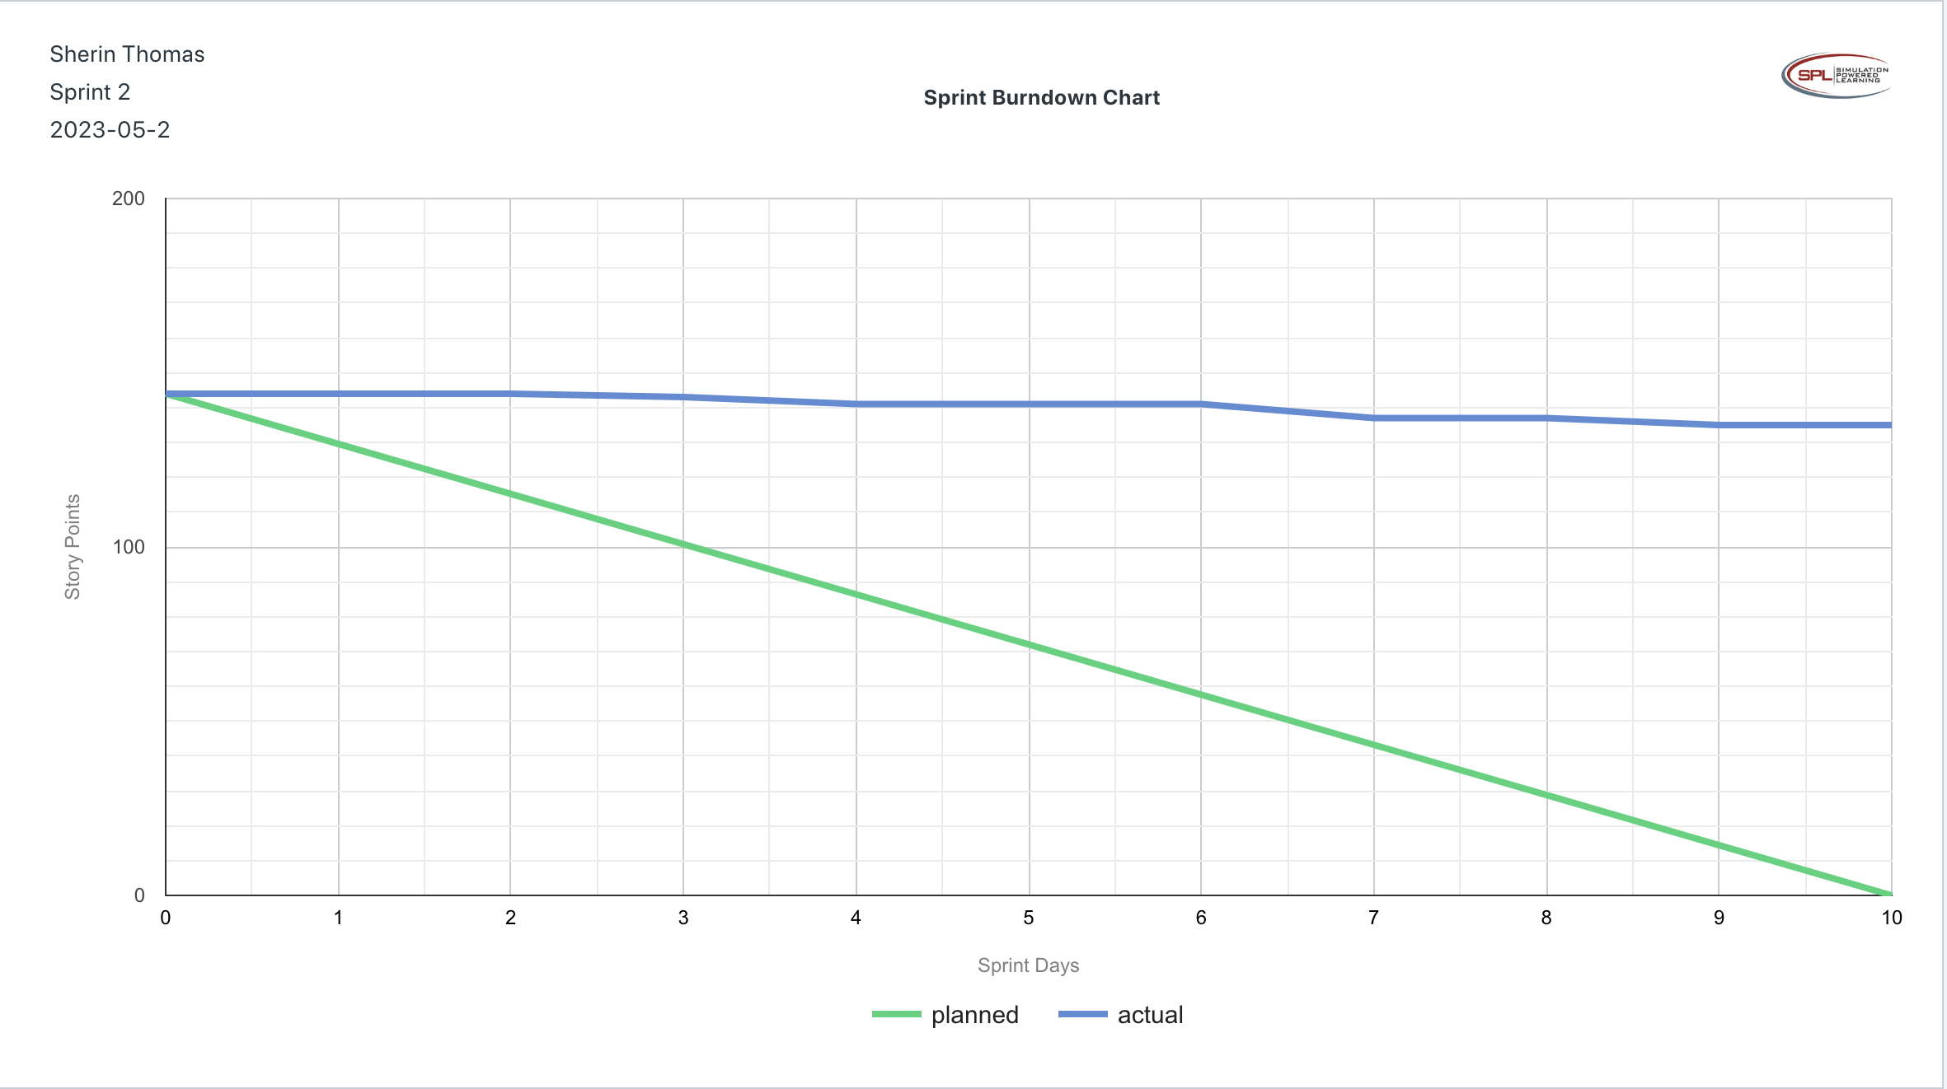

**Velocity Trend**

After competing sprint 2, paste the sprint 2 Velocity Chart below:

**Answer**

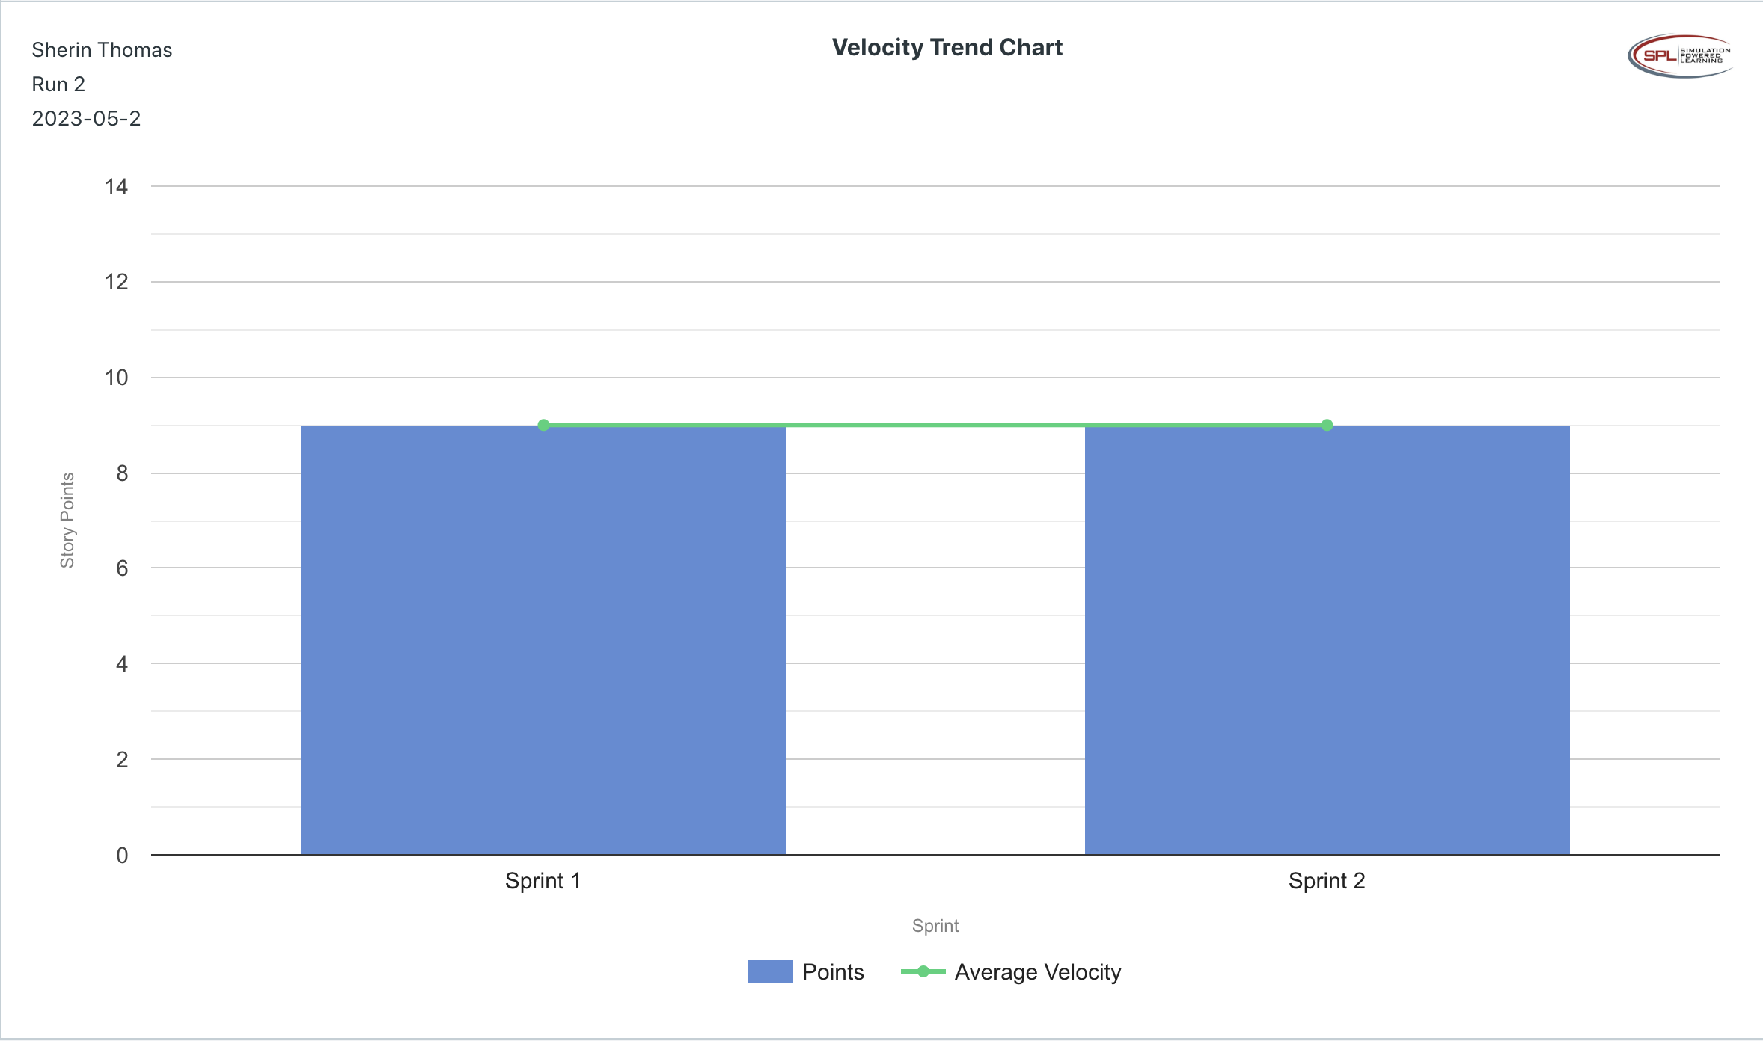

**Retrospective Meeting:**

How did you do in this Sprint?

**Answer**

* We did the exact same number of user stories and story points as Sprint 1. Since we did not improve in our velocity, we are even further behind schedule, which is why we rate this Sprint a 1/5.

What problems, if any, did you encounter as you were executing the sprint?

**Answer**

* We still have developers missing scrum activities, even the ones who attended 1-on-1 sessions during the last Sprint.
* We had one developer, Yee, who stated that she “prefer to develop software alone. I don´t need other developers getting in my way and slowing me down.” This told us that the Agile Bootcamp did not set the foundation of how Agile works. Thus, we reminded her by stating, “This is an Agile development Yee, we work as a team. Don´t look at it as other developers are getting in your way, look at it as everyone is helping everyone else be as productive as possible.”
* We received a comment that there is a growing concern about the projected cost of the fancy benefits website.
* Farley Gnu, our product owner, wanted to add user stories while we were running a sprint. We had to remind him that once a Sprint starts, we can’t add user stories until the Sprint Review/ Backlog Refinement. It seems that a lot of people on the team aren’t familiar with how Agile processes work.
* We received a team comment that “We tend to talk about the same things in the daily scrums. We think we can be more productive if we only have the scrums on Tuesdays and Thursdays.” While we offered to talk about it during the next retrospective, we still need to maintain the importance of Daily Stand Ups

What changes, if any, are you are planning to make in the next sprint?

**Answer**

* We are going to continue to reprioritize what user stories will be worked in Sprint 3, meaning the current Sprint 3 user stories will be pushed back, and whatever is left over from Sprint 1 and 2 will be given first priority in Sprint 3.
* While we could give another training session to team members since many are not aware of Agile principles, we noticed how the Agile Bootcamp Team training in Sprint 1 didn’t do much; hence, rather than focusing on trainings, we will focus on increasing team moral and energy through rewards and keeping the calendar as minimal as possible (only schedule necessary activities), so there is more time for developing.

**Answer following questions based on this Sprint:**

What is the velocity (in story points) for the sprint?

**Answer**

* 9 story points

What is the average velocity, minimum velocity, and maximum velocity (in story points) for the project across all sprints that have been completed so far?

**Answer**

* Average: 9 story points
* Minimum: 9 story points
* Maximum: 9 story points

Based on the current status of your project, do you believe that you will be able to complete the mandatory (or required) stories in the product backlog within the four sprints?  Explain your answer.

**Answer**

* Based on our velocity of Sprint 1 and Sprint 2, we do not think we will be able to complete our MVP user stories unless a significant increase in velocity occurs in Sprint 3 and 4. We’ve completed 8 of the MVP user stories out of the 18, which gives us hope, since we are almost halfway there. However, we still do not think we will be able to complete the MVP user stories, because we have only completed 16 MVP story points out of the 51 MVP story points.

Based on the current status of your project, do you believe that you will be able to complete all stories in the product backlog within the four sprints planned? Explain your answer.

**Answer**

* Our developers have not been able to complete all the user stories necessary for the previous sprints, meaning we are currently behind schedule. Hence, based on the velocity of previous sprints, we believe we will not be able to complete all stories in the PBI within four sprints.

**Sprint 3 - Week 5 and Week 6 (10 points)**

**Product Backlog (one screen shot for sprint 3)**

* Paste the screen shot of your product backlog below.

**Answer**

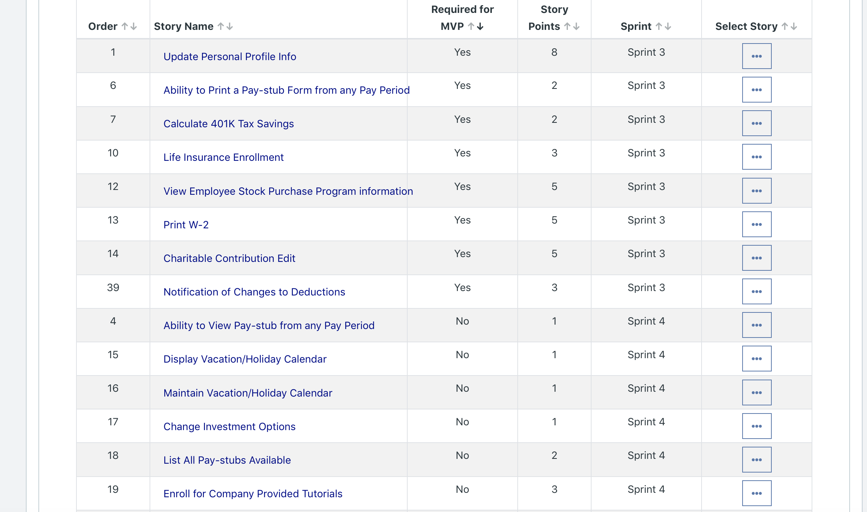

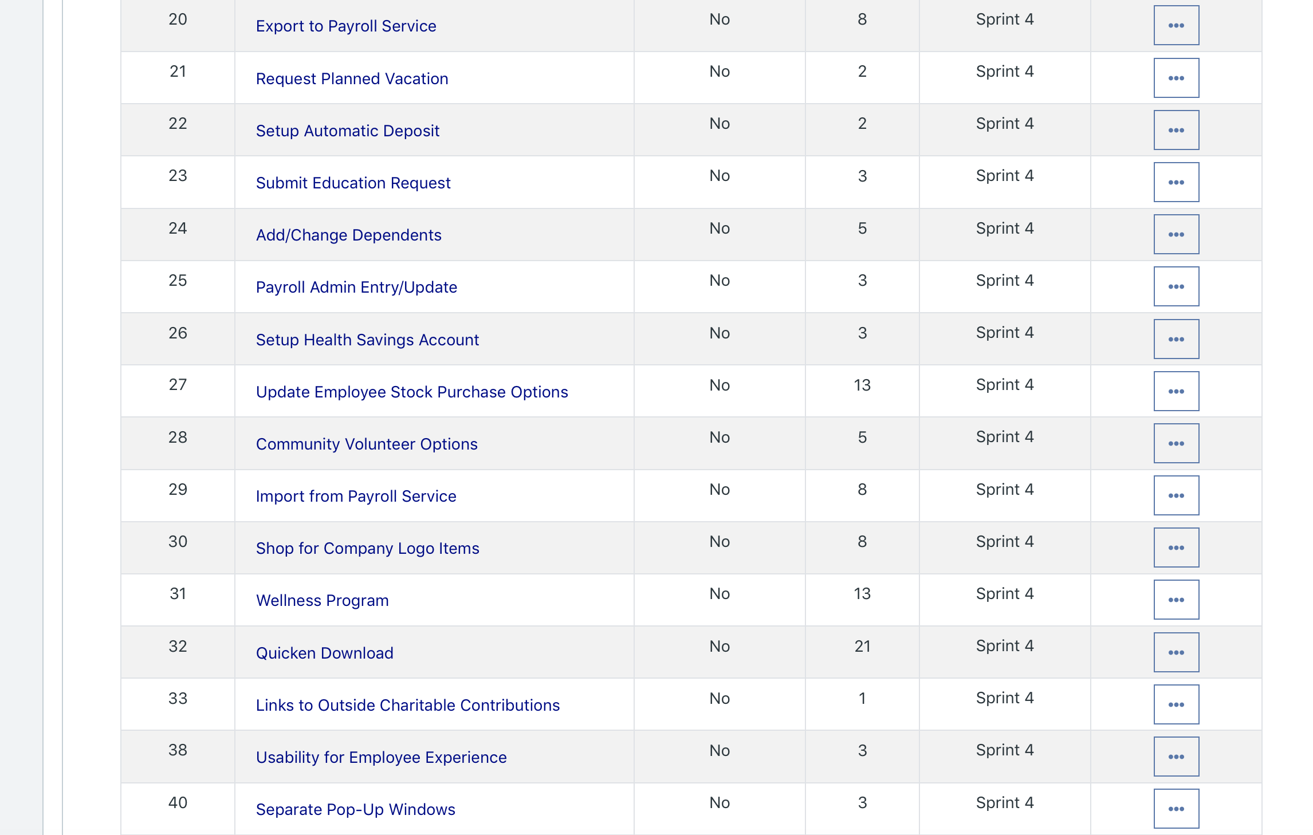



* Please explain what you did in grooming the user stories in your Product Backlog and your reasoning for these decisions.

**Answer**

* Since we are short on time (only 2 more sprints) to complete our MVP stories, we removed anything from Sprint 3 that is not an MVP user story and added it to Sprint 4. Then we prioritized all remaining MVP user stories from Sprint 1 and Sprint 2 that have yet to be completed as the highest priority in Sprint 3.

**Scrum Board**

Scrum Board screen shot before sprint 3 has Started

**Answer**

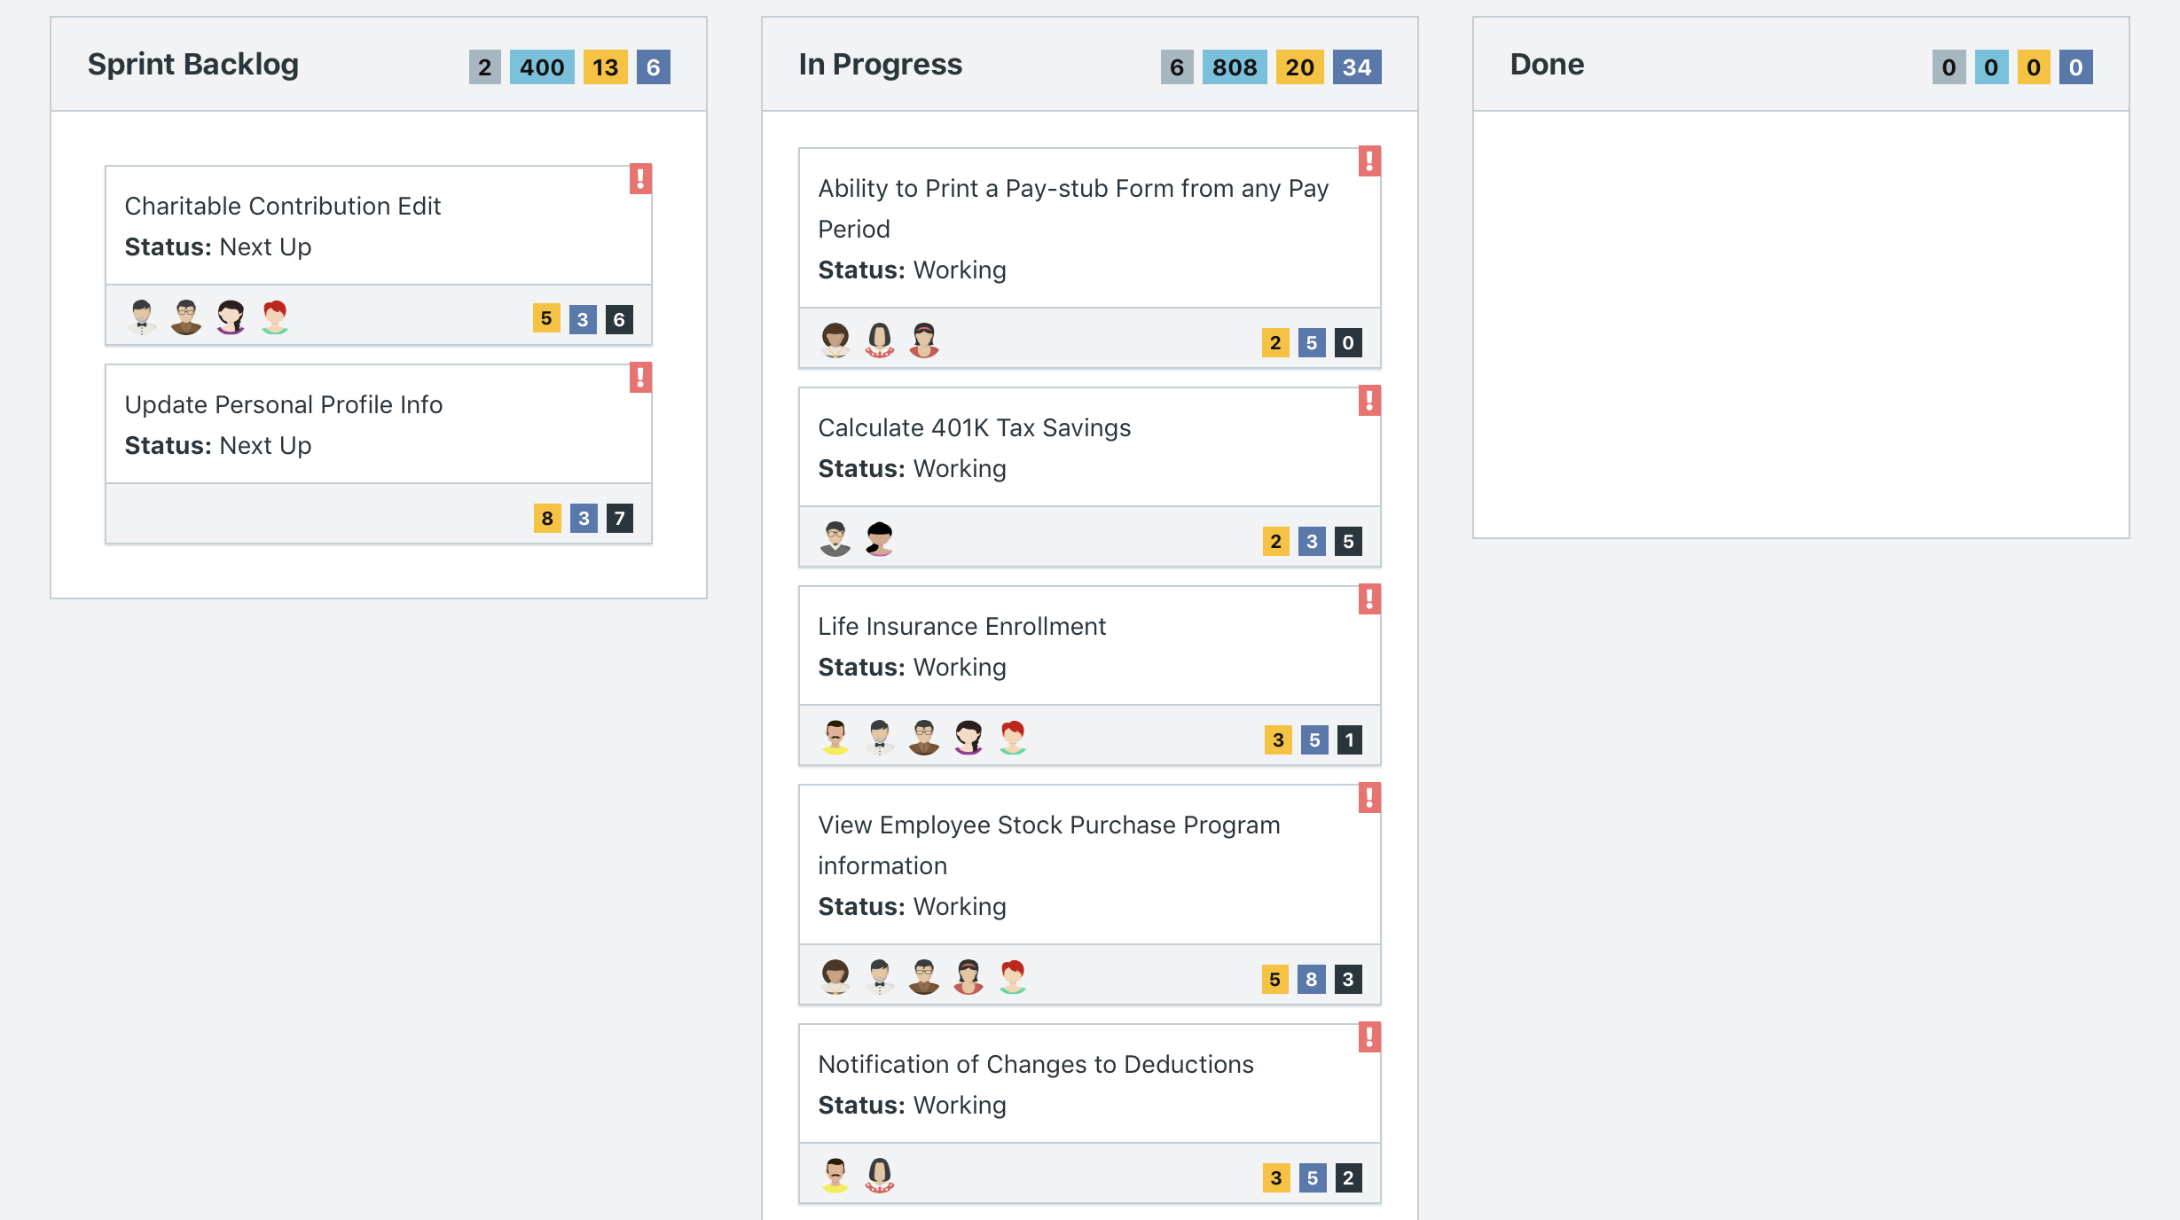



Scrum Board screen shot after 1st week of sprint 3

**Answer**

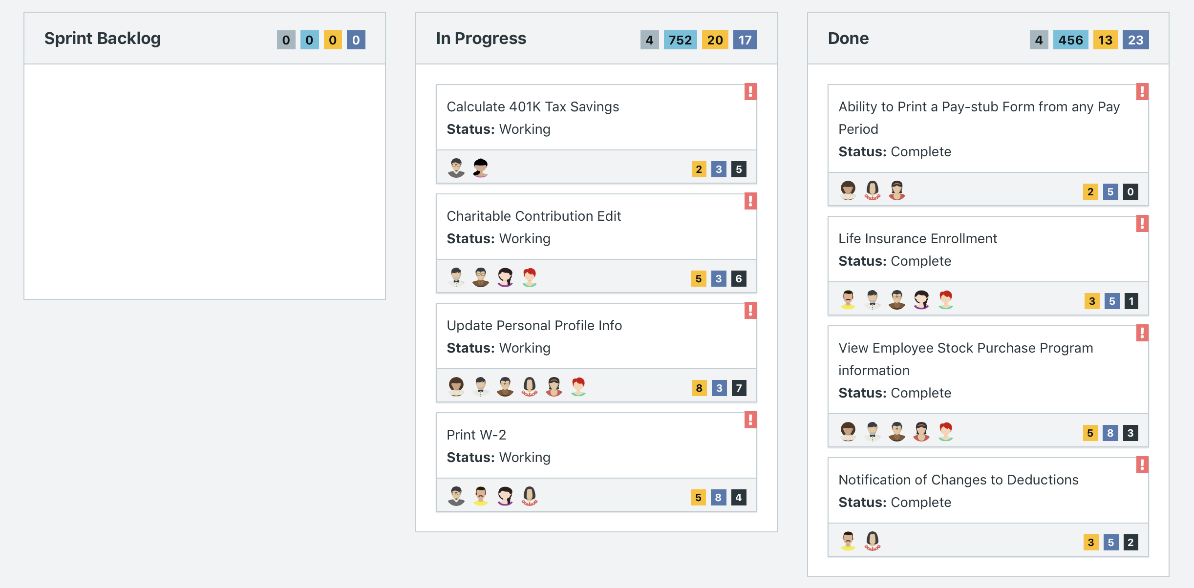

Scrum Board screen shot after 2nd week of sprint 3

**Answer**

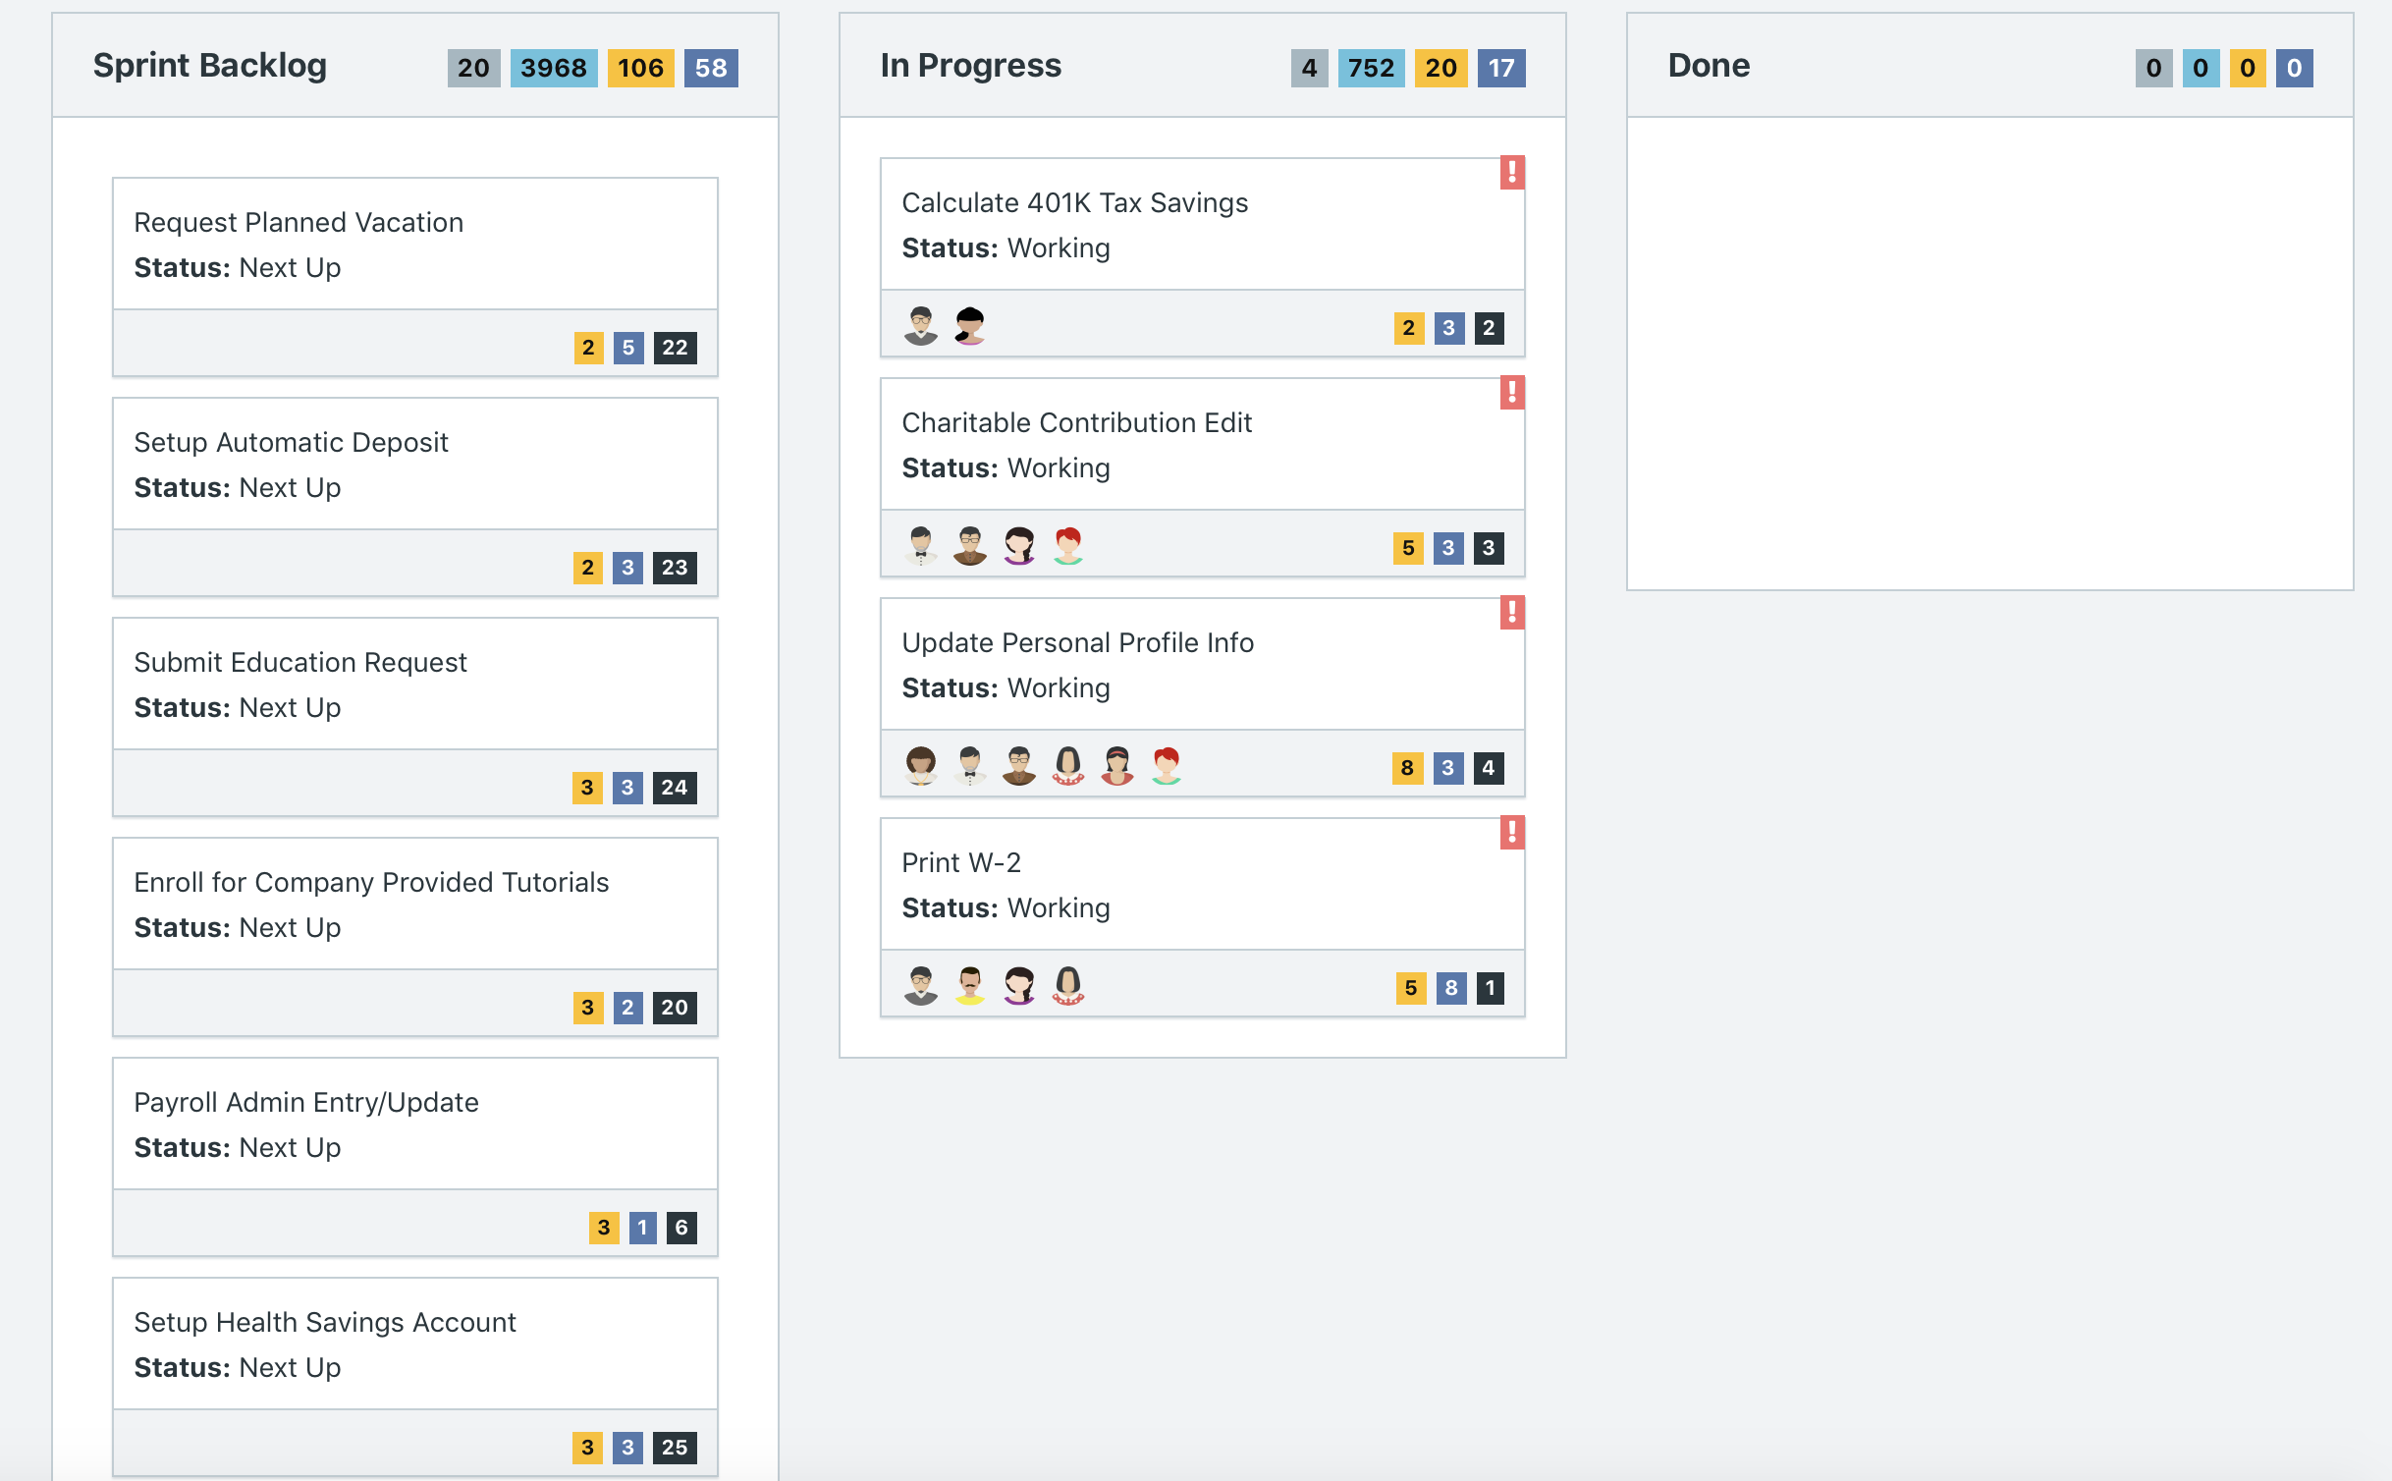

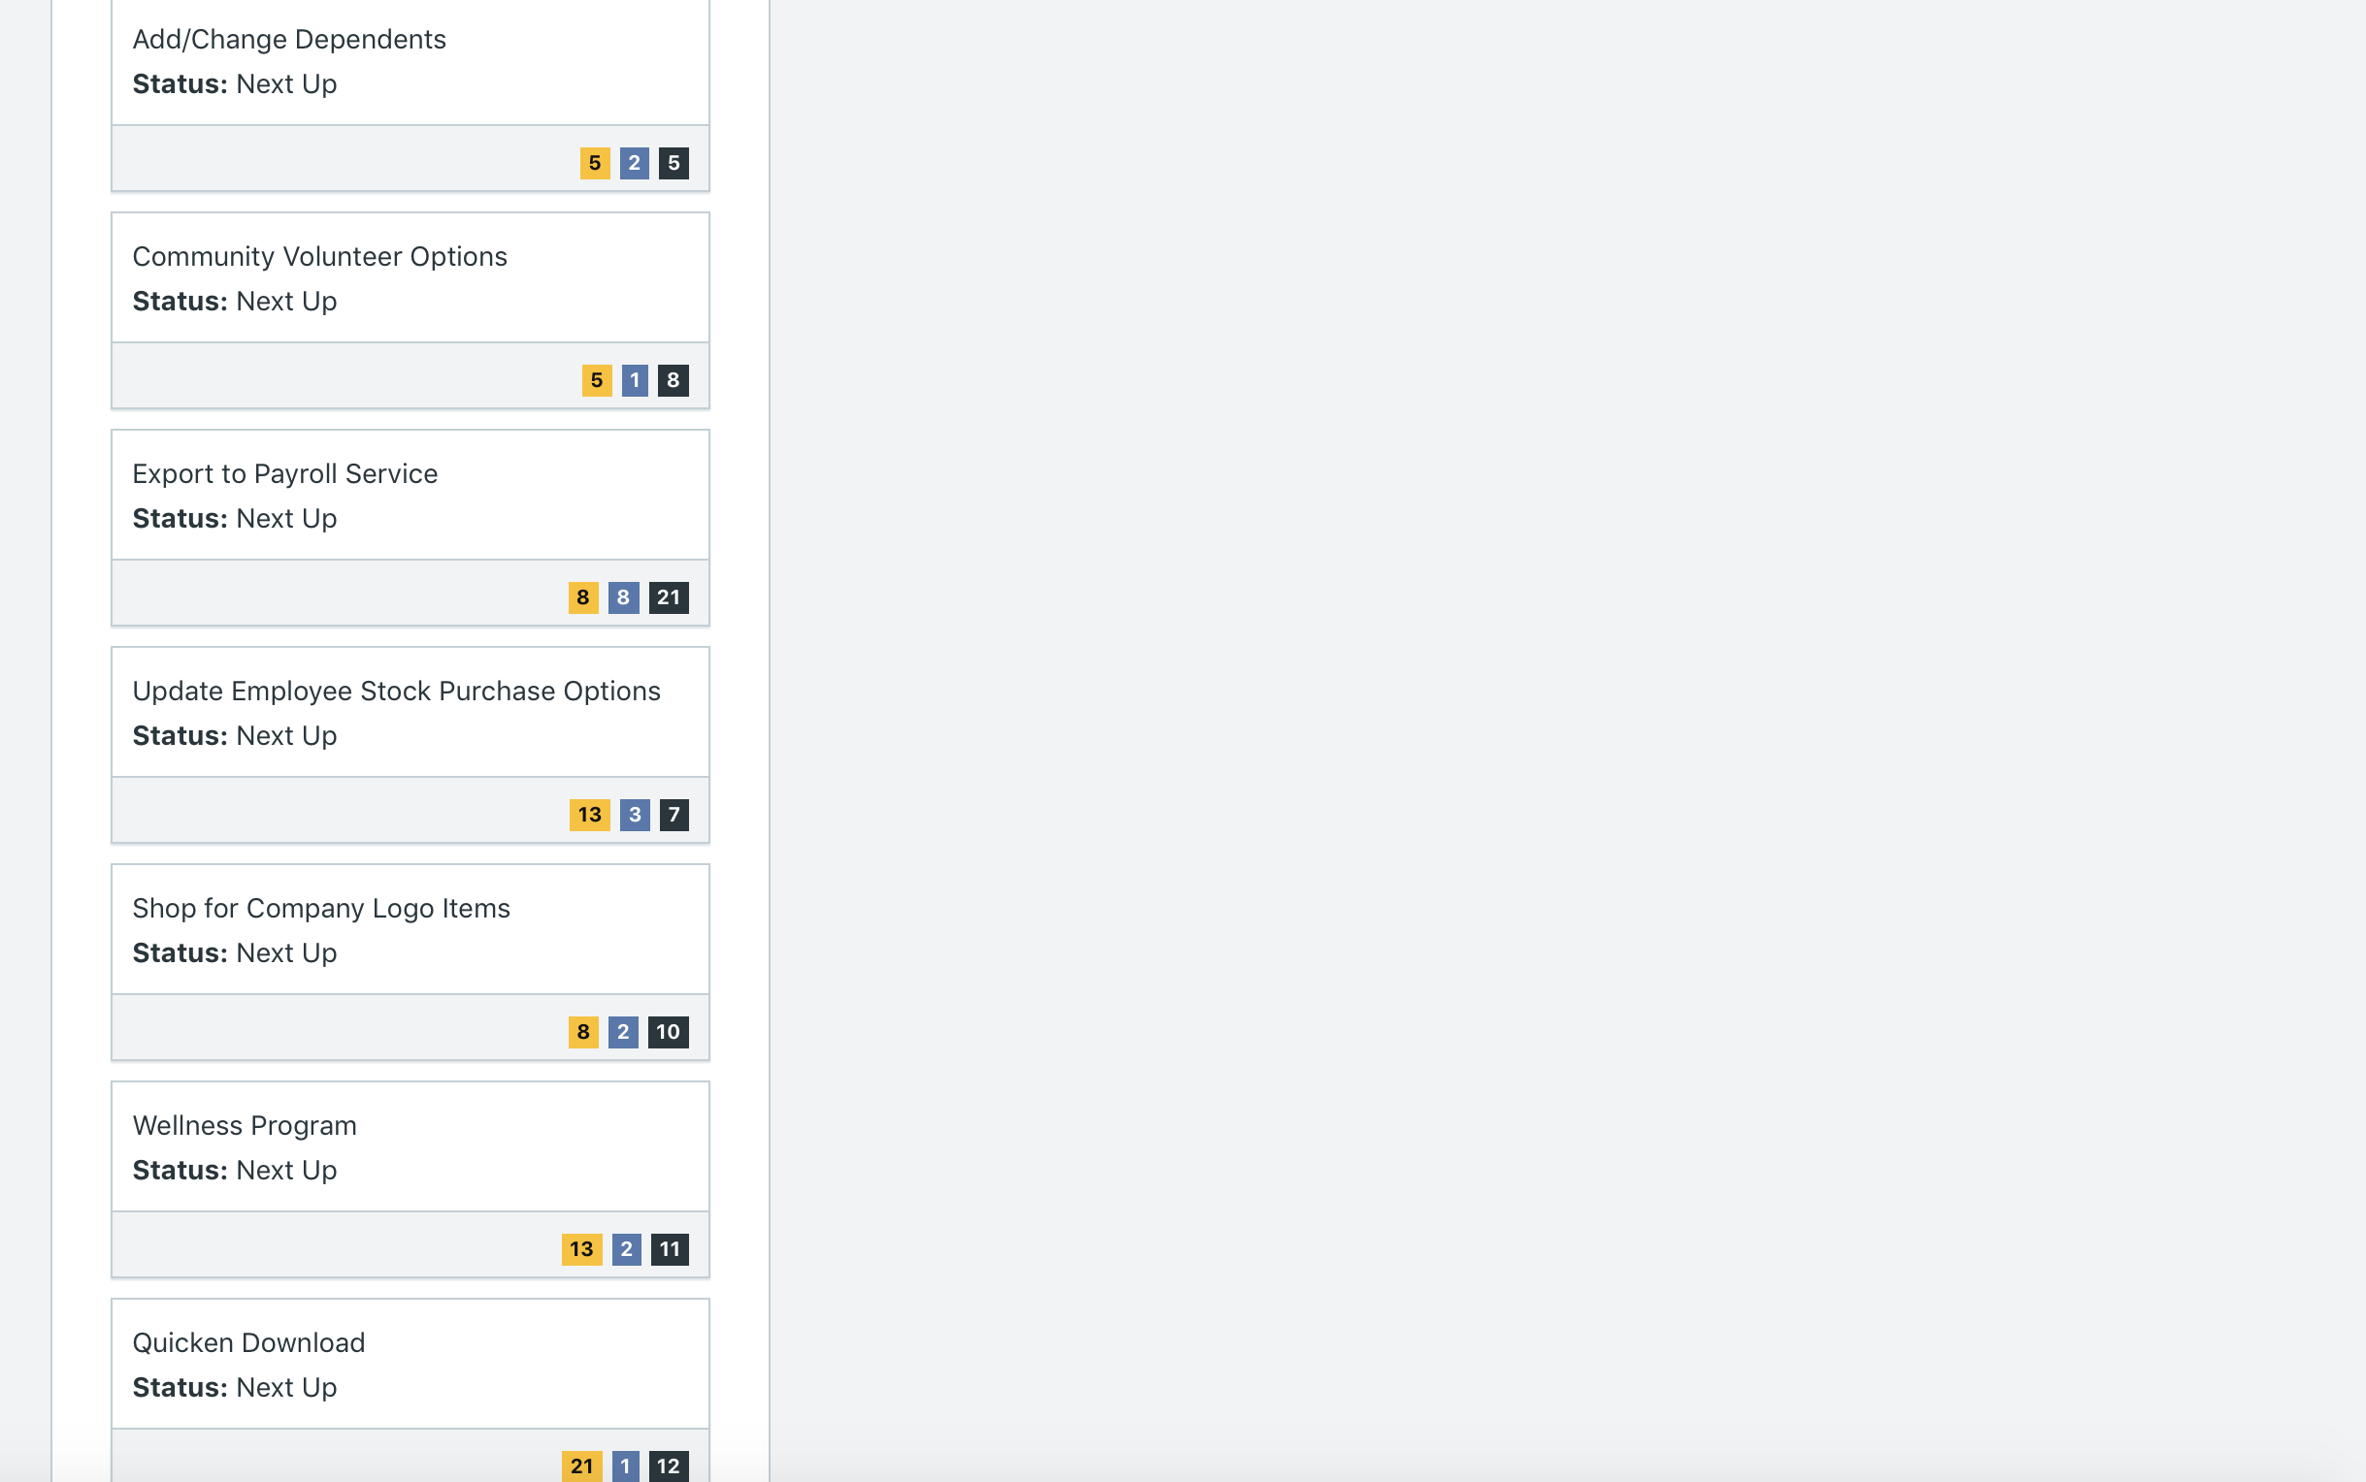

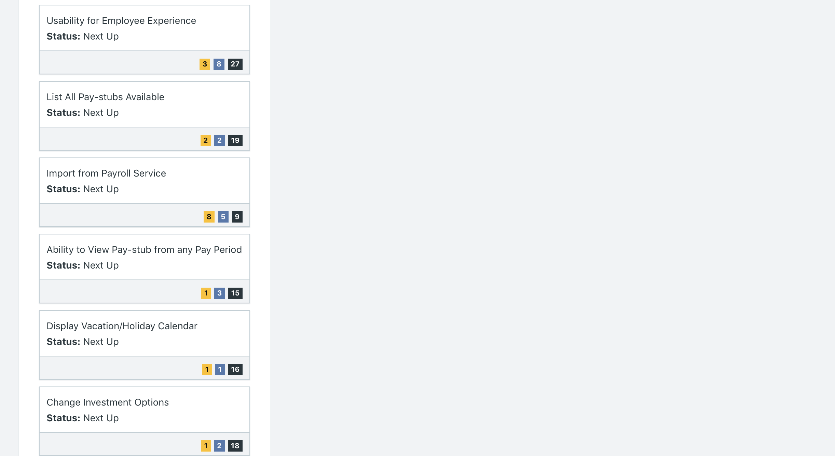

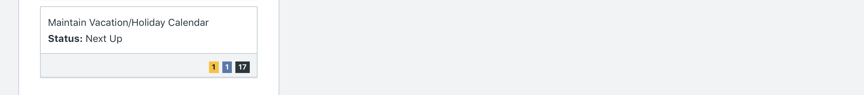

**Calendar**

* Paste the screen shot of your calendar for sprint 3

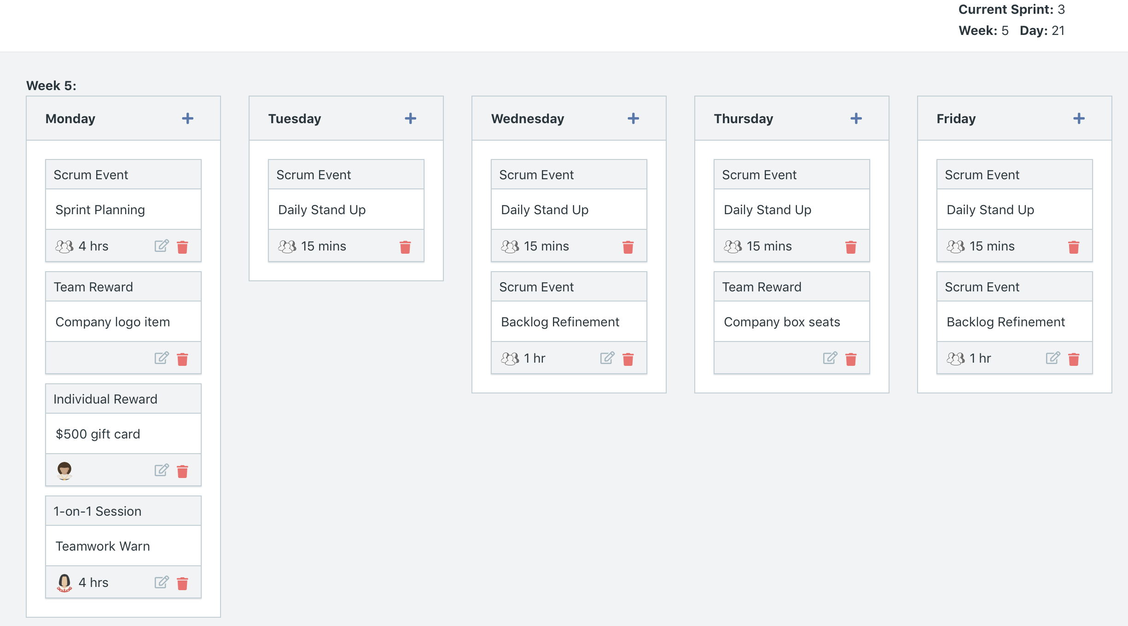

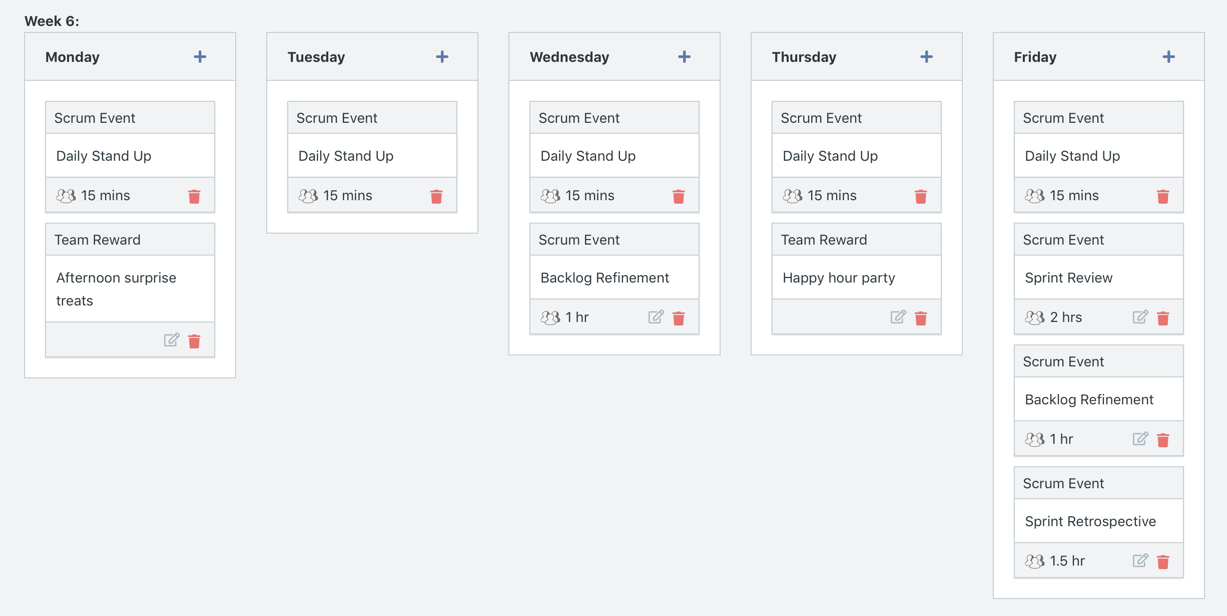

**After Week 5**

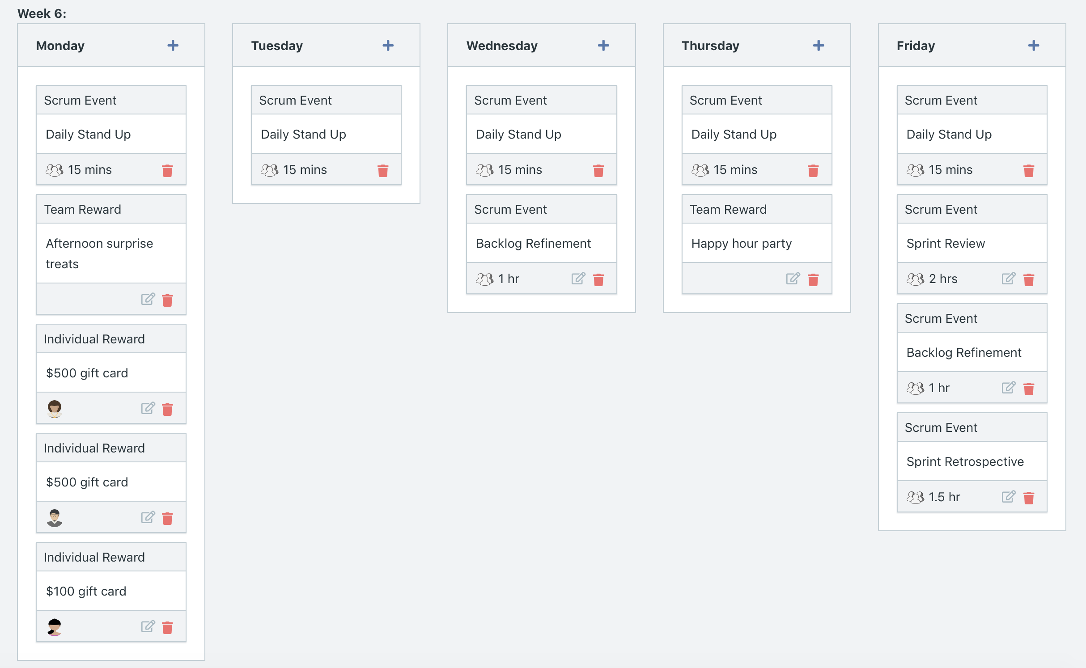

Explain the reason why you have scheduled the meetings listed shown on your calendar (if any)?

**Answer**

* We added 1-on-1 session for one developer who had multiple missed attendances from the last week of Sprint 2. We made the session about teamwork in hopes of reiterating the importance of having all team members present at scrum activities.
* On Monday of Week 8 we provided one of our team members with a $500 gift card; this is because in the members workload graph, we noticed that she has been working extra time, as in beyond her work capacity. Hence, we wanted to show her our appreciation for all the time she has put in for completing user stories assigned to her.
* In Week 8, we also added two team rewards as usual (company logo and happy hour party) to encourage team morale, connection, and collaboration.
* Additions after running Week 8
  + We looked at member workload again after running week 8; the individual with the greatest number of overworked hours was gifted $500 gift card, and two other individuals were gifted $100 gift card for their extra hours of work outside of capacity. Once again, this was done to show appreciation for team members for their work and to illustrate that as product managers, we recognize and appreciate them.
  + In Week 9, we also added two team rewards as usual (afternoon treats and happy hour) to encourage team morale, connection, and collaboration.

**BurnDown**

After competing sprint 3, paste a screen shot of the sprint 3 Burn Down Chart below.

**Answer**

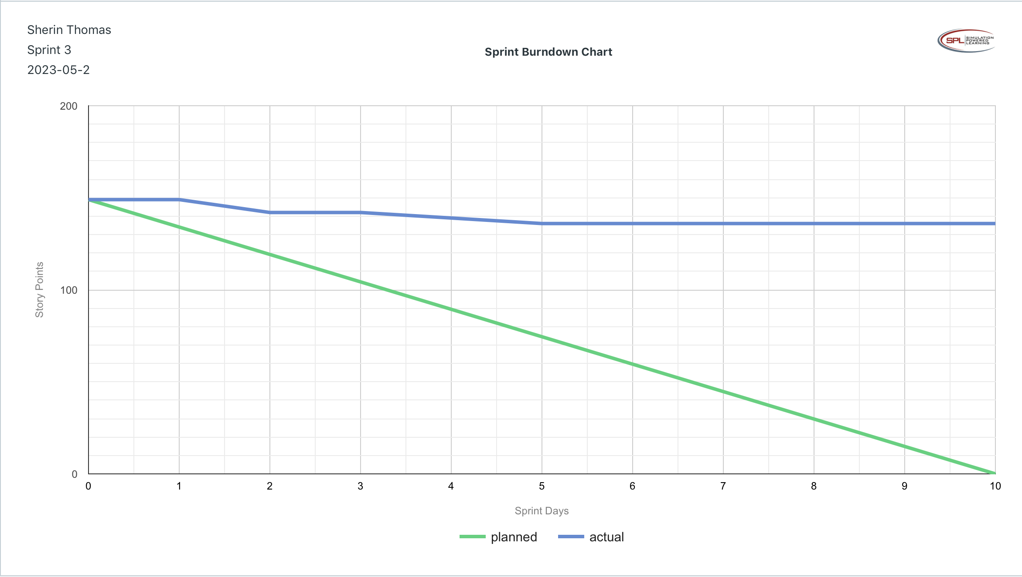

**Velocity Trend**

After competing sprint 3, paste the sprint 3 Velocity Chart below:

**Answer**

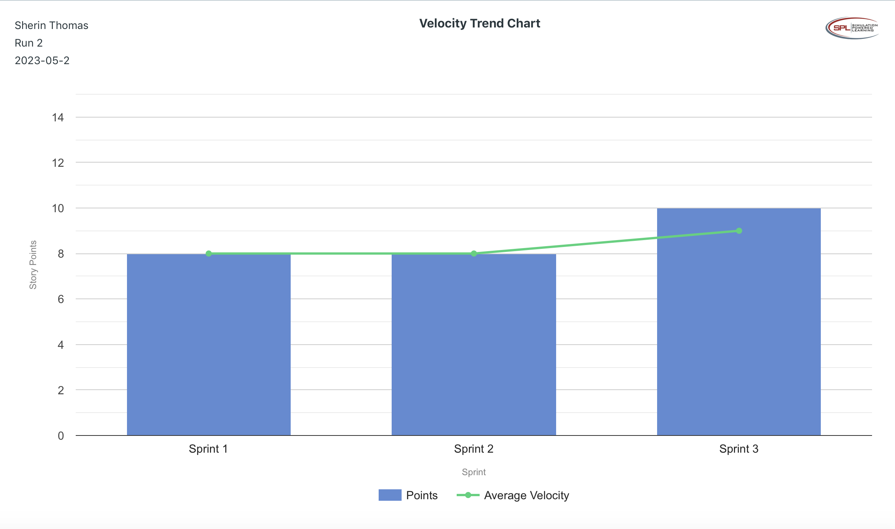

**Retrospective Meeting:**

How did you do in this sprint?

**Answer**

* We improved our velocity by a few points. Although it’s good that our velocity increased, it did not increase significantly. Moreover, Farely reported that we have bugs in our MVP, so we had to redo our MVP user stories, putting us even more behind schedule for MVP completion milestone. Based on these reasonings, we rate Sprint 3 as a 2/5.

What problems, if any, did you encounter as you were executing the sprint?

**Answer**

* Farley notified that classified documents were found in the trash can, so will have to conduct security training next week, which means more hours are taken away from developers’ time for their last sprint meant to complete MVP user stories.
* Farley notified us that “after seeing the Review, there are serious bugs that need to be fixed before the team can move forward with new stories.” When checking the End of Run report, we saw that we had originally completed 14 MVP user stories; but due to the bugs, we went down to only 11 completed MVP user stories. This means we are on a serious time constraint to provide 7 MVP user stories within our next Sprint.
* We received feedback from business stakeholders that our demo stories were too technical and they did not quite understand the context. Hence, we need to focus on providing business context to stakeholders.

What changes, if any, are you are planning to make in the next sprint?

**Answer**

* For Sprint 4, the only user stories we should add to the Sprint 4 backlog are the remaining MVP user stories. We know that at this point, we cannot complete all user stories for this product. Hence, all focus should be on MVP user stories to complete them by the deadline, which is the end of Sprint 4.
* We are going to keep the calendar even more simple – as in no 1-on-1 sessions despite attendance issues and limited team rewards except for the end of sprint.
* Lastly, whatever remaining available hours developers have will be assigned to the MVP user stories on the scrum board. We will be continuously assigning developers as we run Sprint 4, rather than only re-checking assignments at the end of each week.

**Answer following questions based on this Sprint:**

What is the velocity (in story points) for the sprint?

**Answer**

* 10 story points

What is the average velocity, minimum velocity, and maximum velocity (in story points) for the project across all sprints that have been completed so far?

**Answer**

* Average: 9 story points
* Minimum: 8 story points
* Maximum: 10 story points

Based on the current status of your project, do you believe that you will be able to complete the mandatory (or required) stories in the product backlog within the four sprints?  Explain your answer.

**Answer**

* We have 7 of the 18 MVP user stories left. Based on reports, we’ve only been able to complete 3-4 MVP user stories per sprint. Hence, trying to complete 7 user stories is nearly double the work compared to our previous sprint trends. Moreover, by Sprint 3 we have only completed 26 story points out of the 51 MVP story points required by our release plan. Meaning, developers will have to complete over 30 story points in one sprint, which is highly unlikely considering that our current velocity has only been 9-10 story points per sprint. Hence, to deliver the MVP user stories on time, developers would need to output 3 times the amount of work done in previous sprints. Based on these reasons, we believe we will not be able to complete all MVP user stories by four sprints.

4. Based on the current status of your project, do you believe that you will be able to complete all stories in the product backlog within the four sprints planned? Explain your answer.

**Answer**

* Our developers have not been able to complete all the user stories necessary for any of the previous sprint, meaning we are currently behind schedule. Moreover, we removed all non-MVP user stories in Sprint 4 to focus on finishing the MVP by Sprint 4. This means no priority is given to non-MVP user stories. Based on these reasons, we believe we will not be able to complete all stories in the PBI within four sprints.

**Sprint 4 - Week 7 and Week 8 (10 points)**

**Product Backlog (one screen shot for sprint 4)**

* Paste the screen shot of your Product Backlog below.

**Answer**

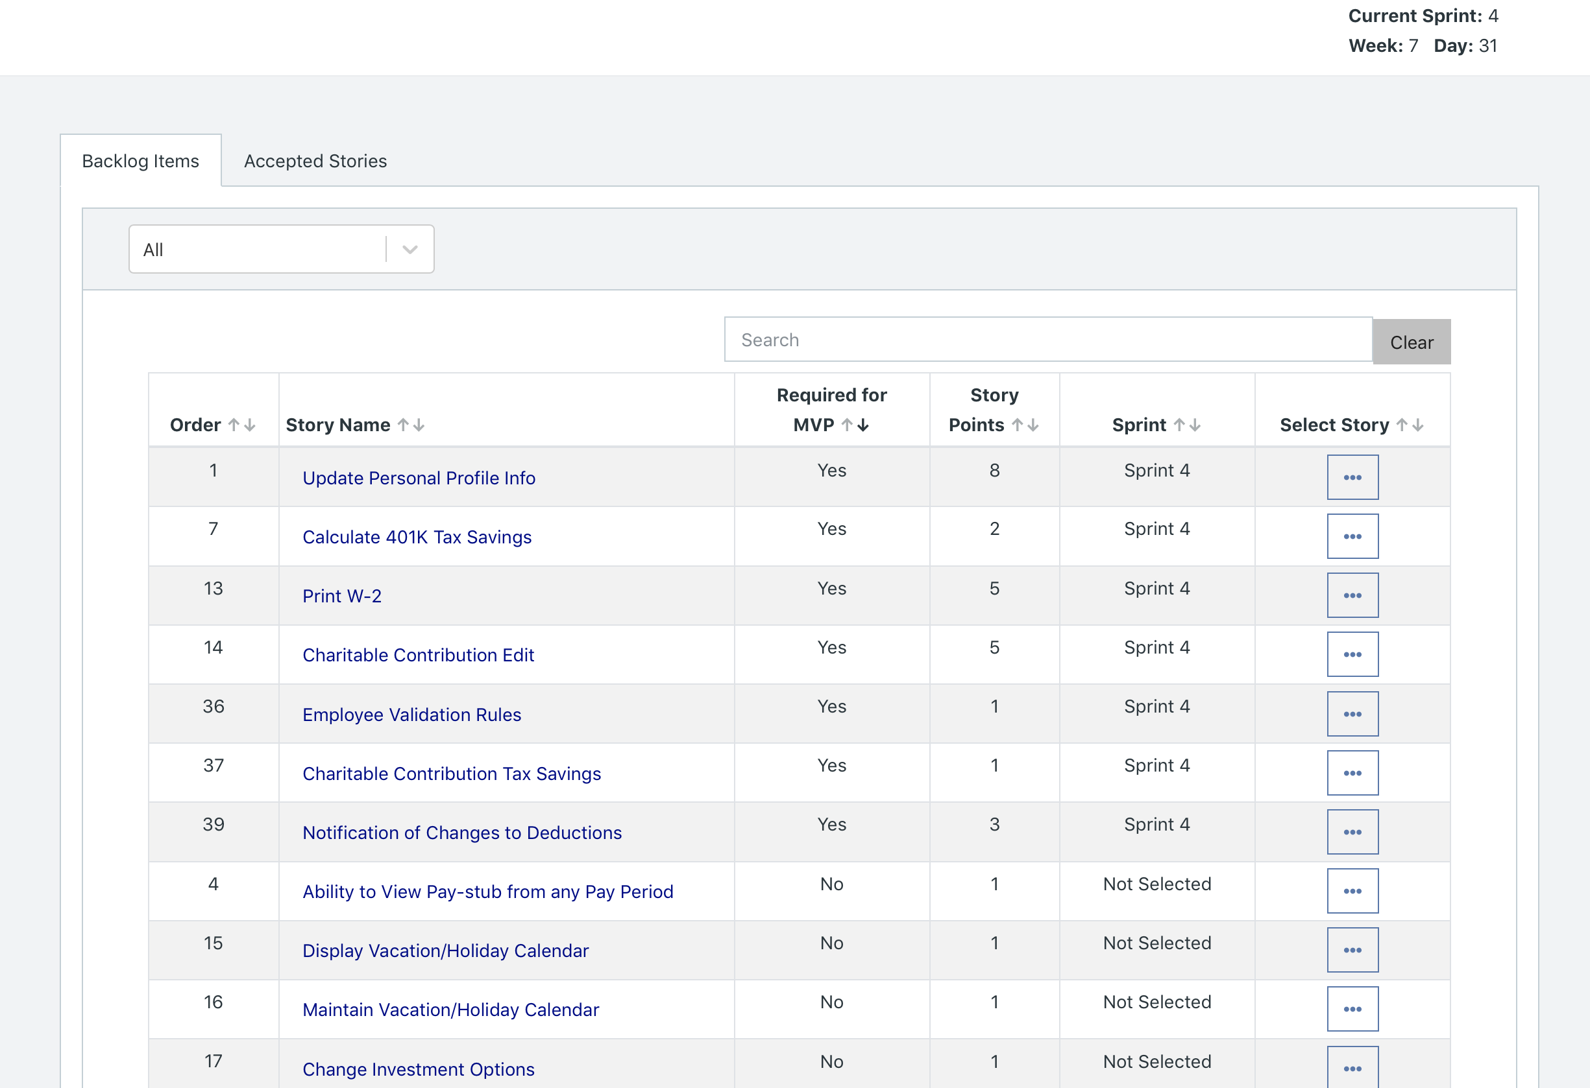

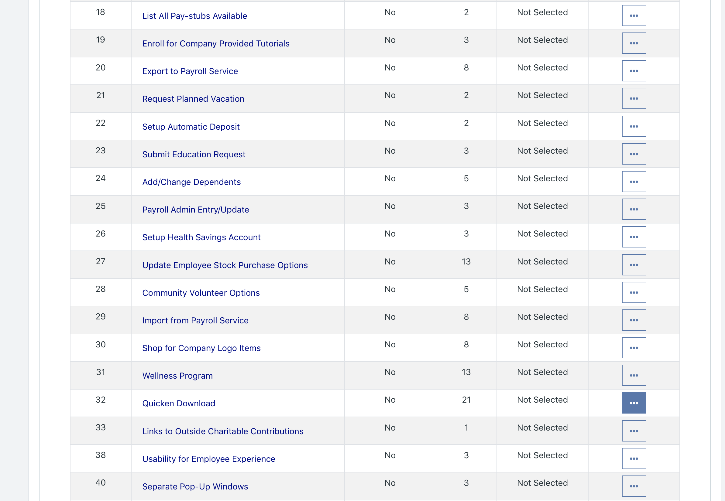



* Please explain what you did in grooming the user stories in your Product Backlog and your reasoning for these decisions.

**Answer**

* We removed all non-MVP user stories from Sprint 4 and organized them as Not Selected. We did this because we were sure that we would not be able to deliver all the stories in our PBI. Hence, our focus should be on delivering all MVP stories by the end of Sprint 4, which is why they are the only ones in Sprint 4.

**Scrum Board**

Scrum Board screen shot before sprint 4 has started

**Answer**

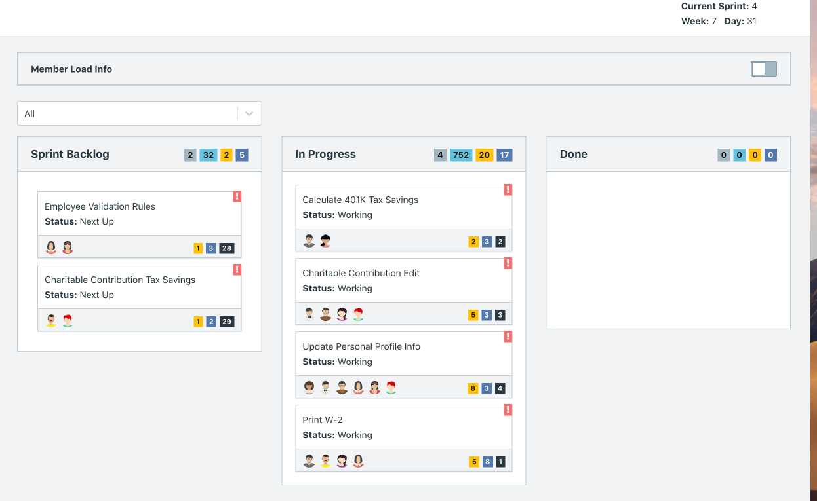

Scrum Board screen shot after 1st week of sprint 4

**Answer**

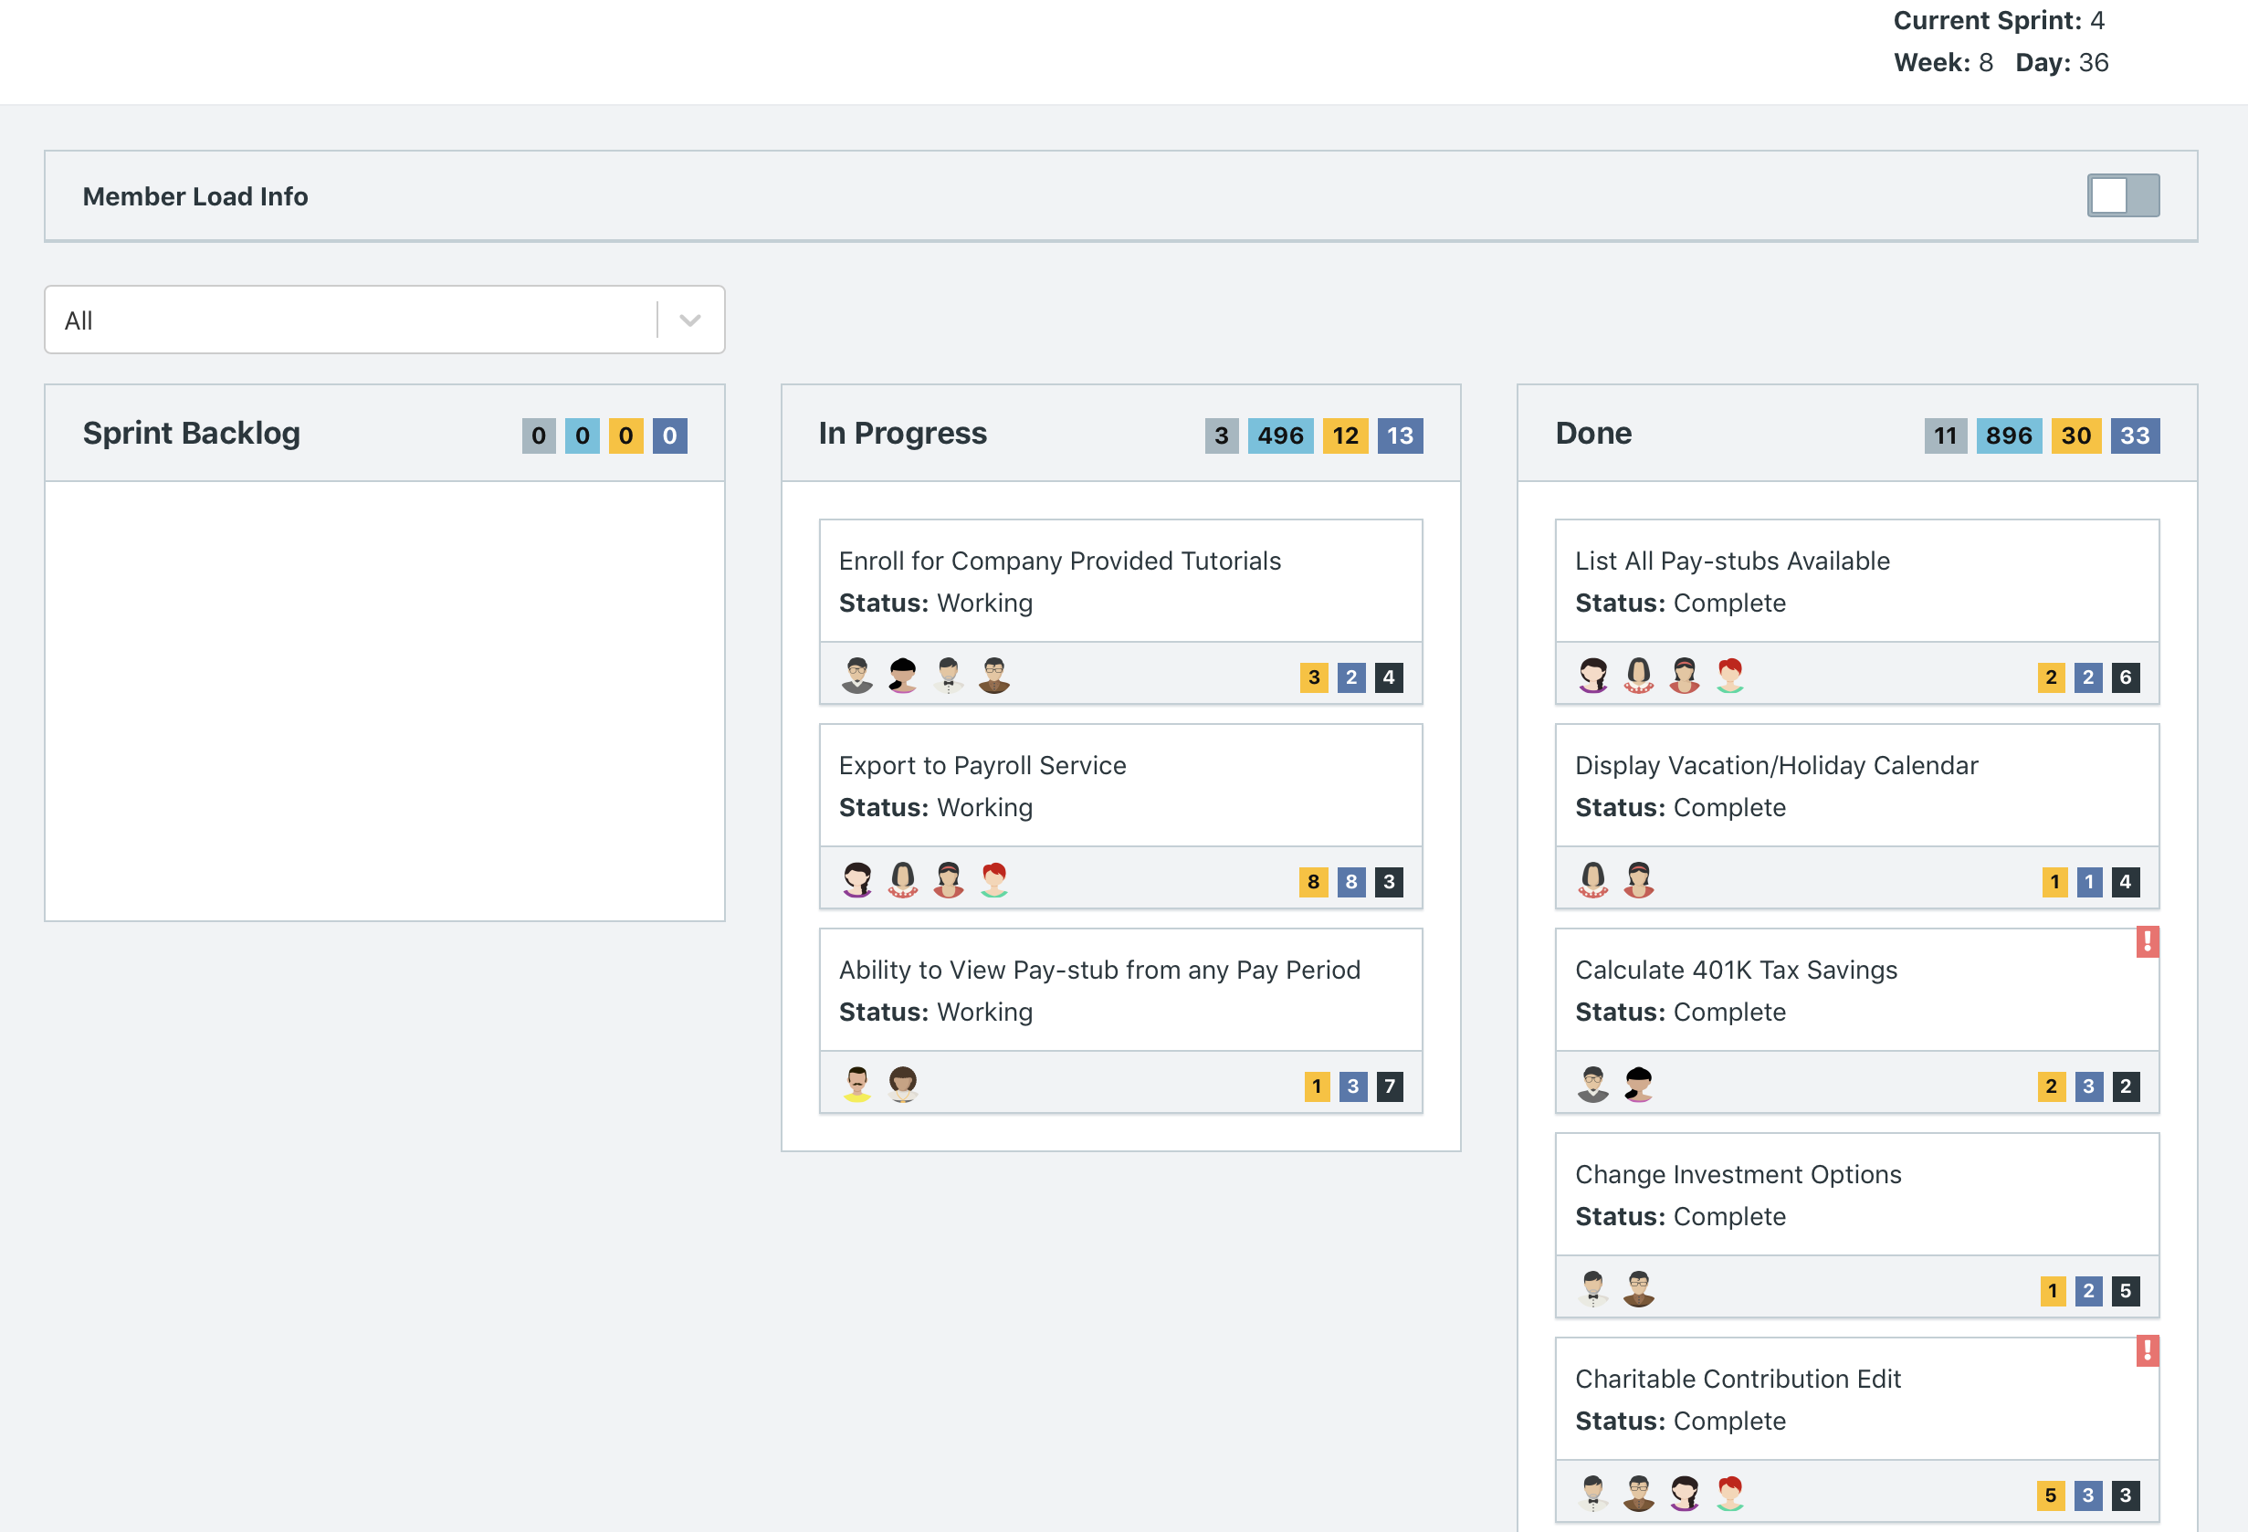

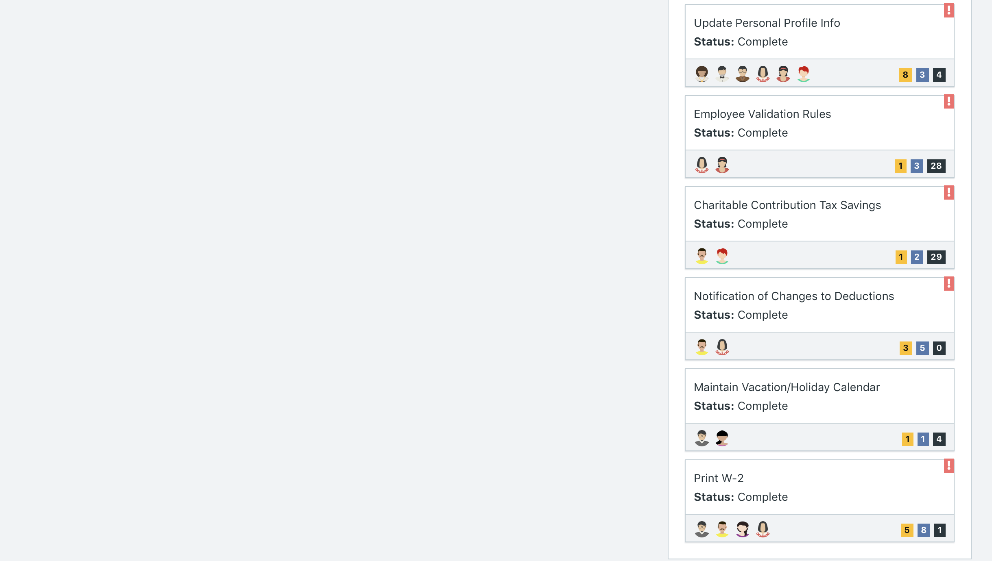

Scrum Board screen shot after 2nd week of Sprint 4

**Answer**

*After Sprint 4 was done, the software only allowed us to access the Reports and would not allow us to go back into Scrum Board. This may be due to the fact that the simulation was completed. Consequently, we have attached a screenshot of End of Run Report for Sprint 4, which like the Scrum Board, showcases which user stories were completed, are in progress, or are Next Up.*

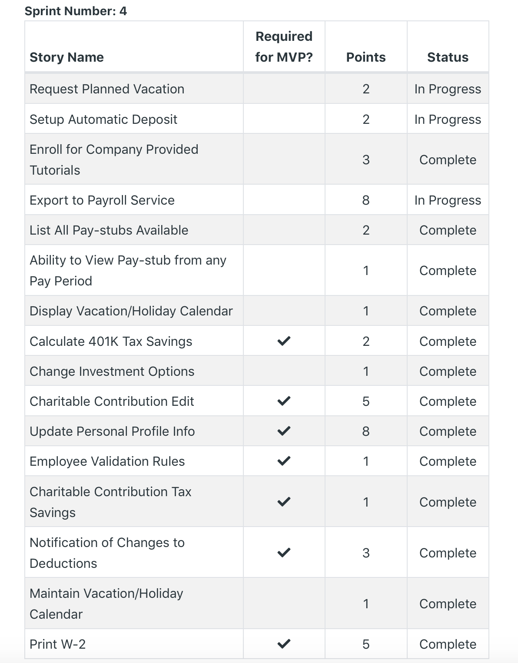

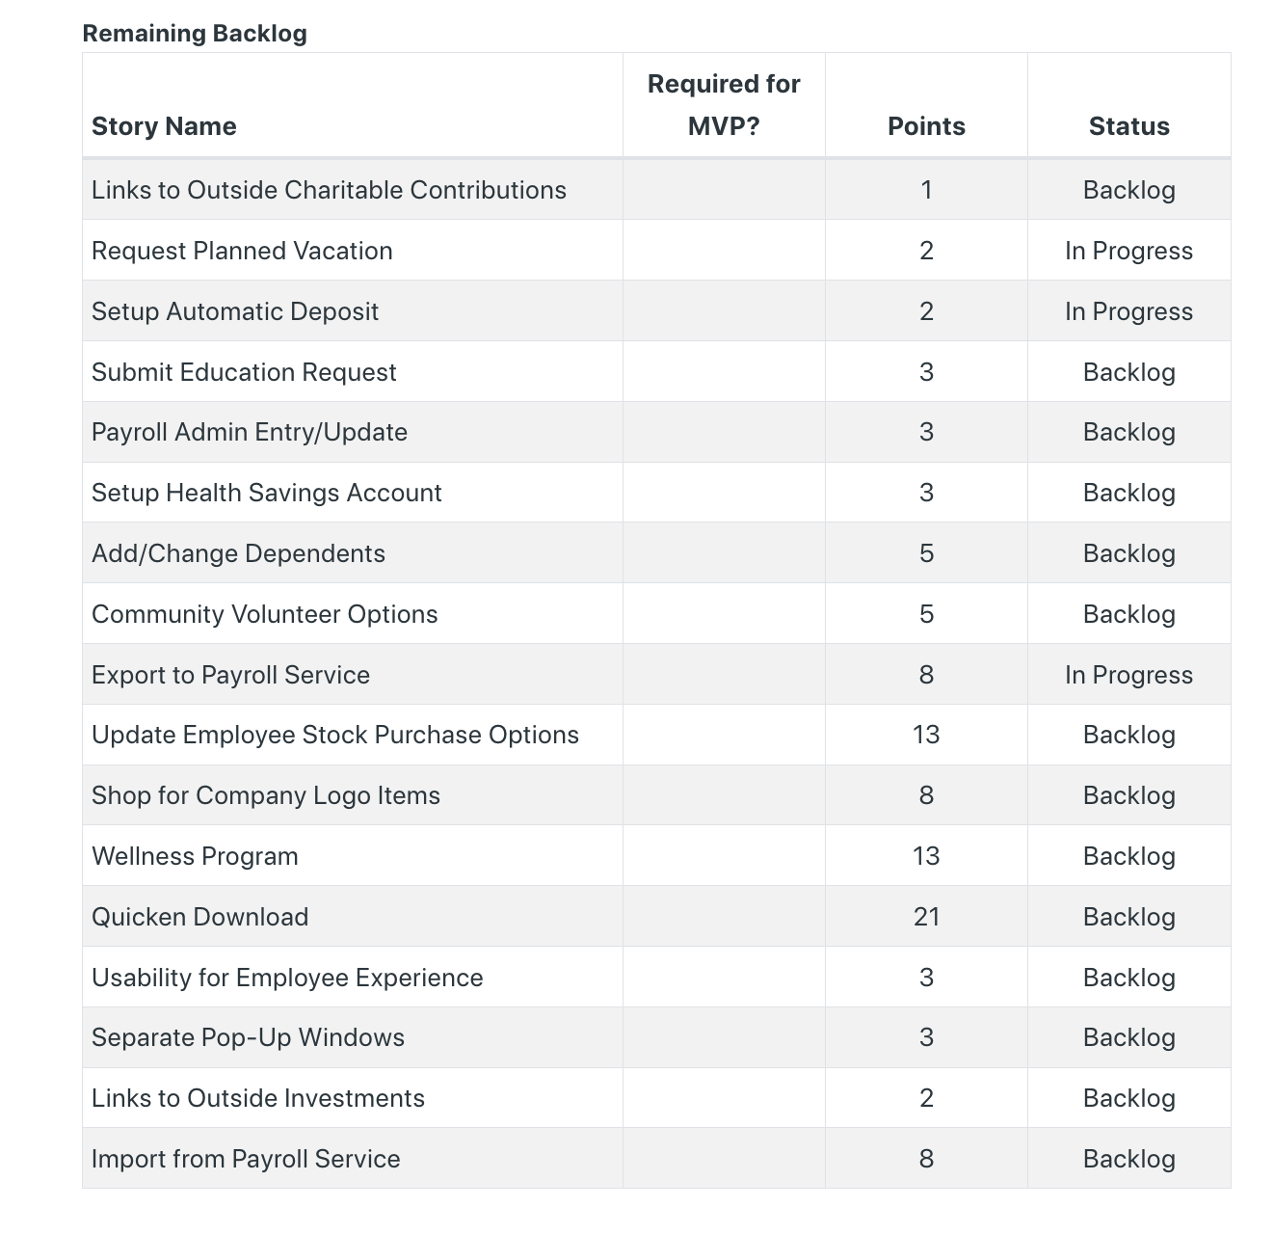

**Calendar**

Paste the screen shot of your Calendar for Sprint 4

**Answer**

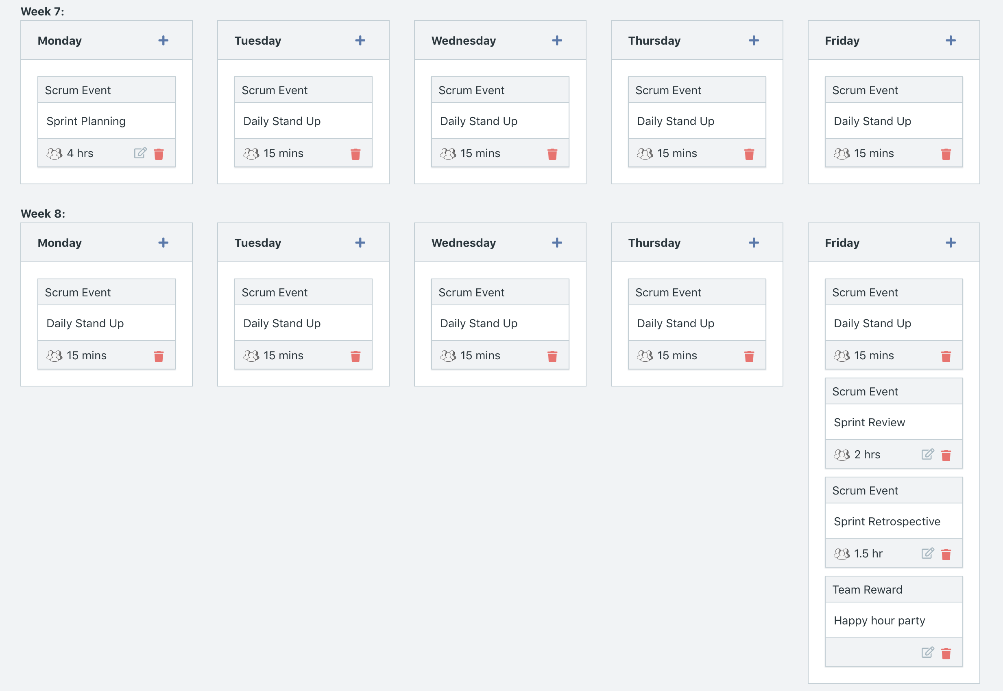

**After Week 7 Additions:**

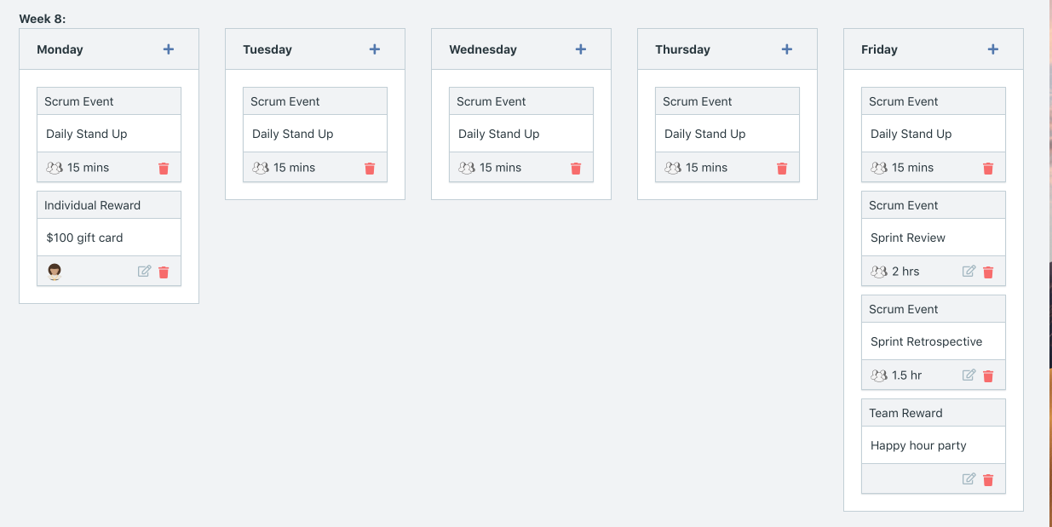

Explain the reason why you have scheduled the meetings listed shown on your calendar (if any)?

**Answer**

* Due to the limited amount of time we have to complete multiple MVP user stories, we only scheduled the required scum activities and did not add any extra activities like 1-one-1 sessions.
* We did add a happy hour party at the end of Week 8 to celebrate the end of Sprint 4 and hopefully celebrate the completion of the MVP.
* Additions after running Week 7,
  + We gave a $100 gift card to Barbra because in Week 7, the team members wanted to host her a wedding party during work hours. However, as product owners, we requested that parties be hosted after work hours, and not during work hours since all available time should be allocated to development. Since we were not able celebrate her wedding party as originally planned, we decided to give her a $100 gift card as a gift for her wedding and appreciation for being present during work hours.

**BurnDown**

After competing sprint 4, paste a screen shot of the sprint 4 Burn Down Chart below.

**Answer**

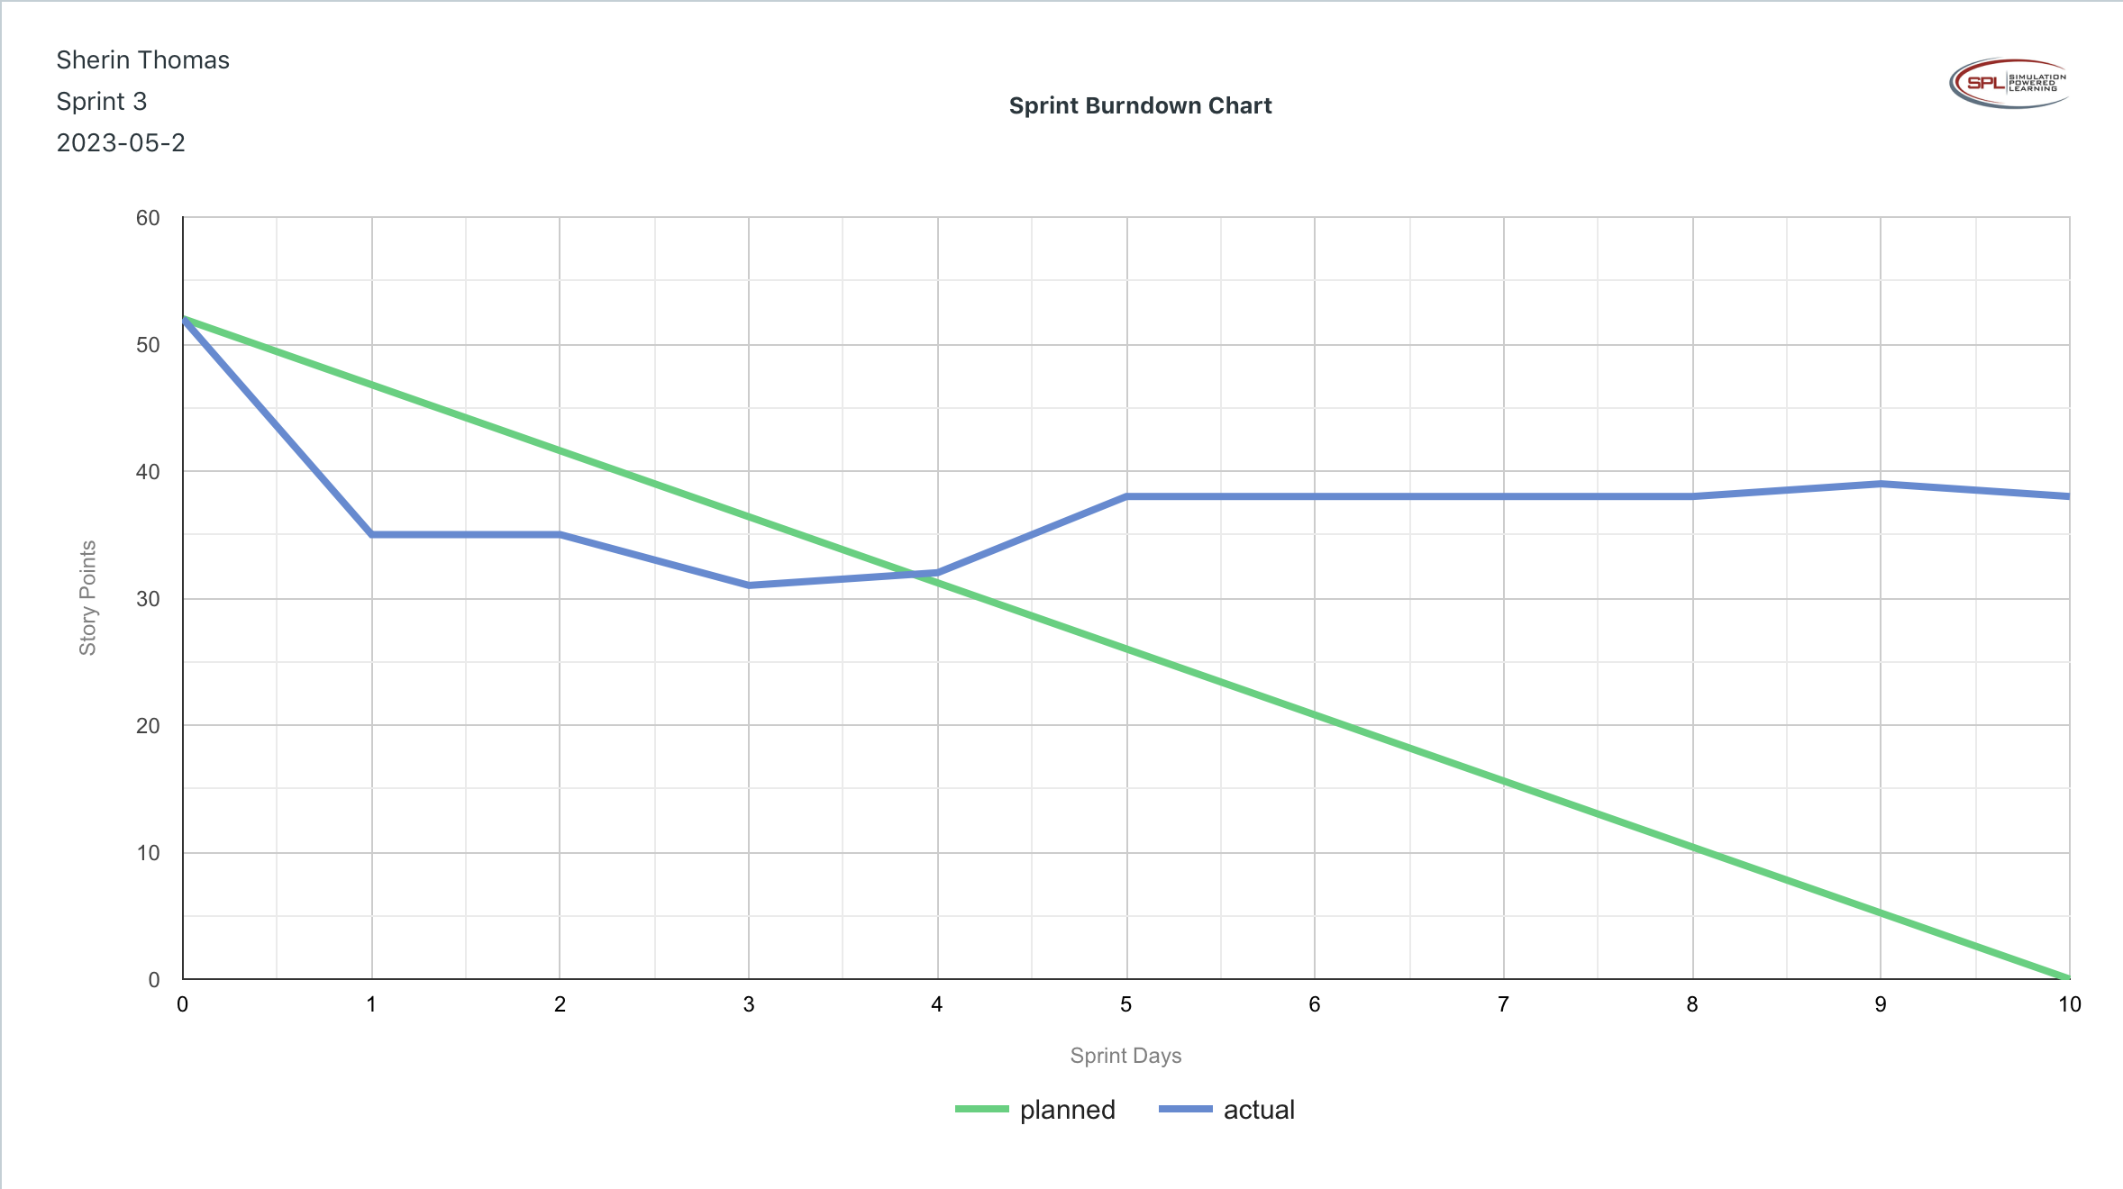

**Velocity Trend**

* After competing sprint 4, paste the sprint 4 Velocity Chart below:

**Answer**

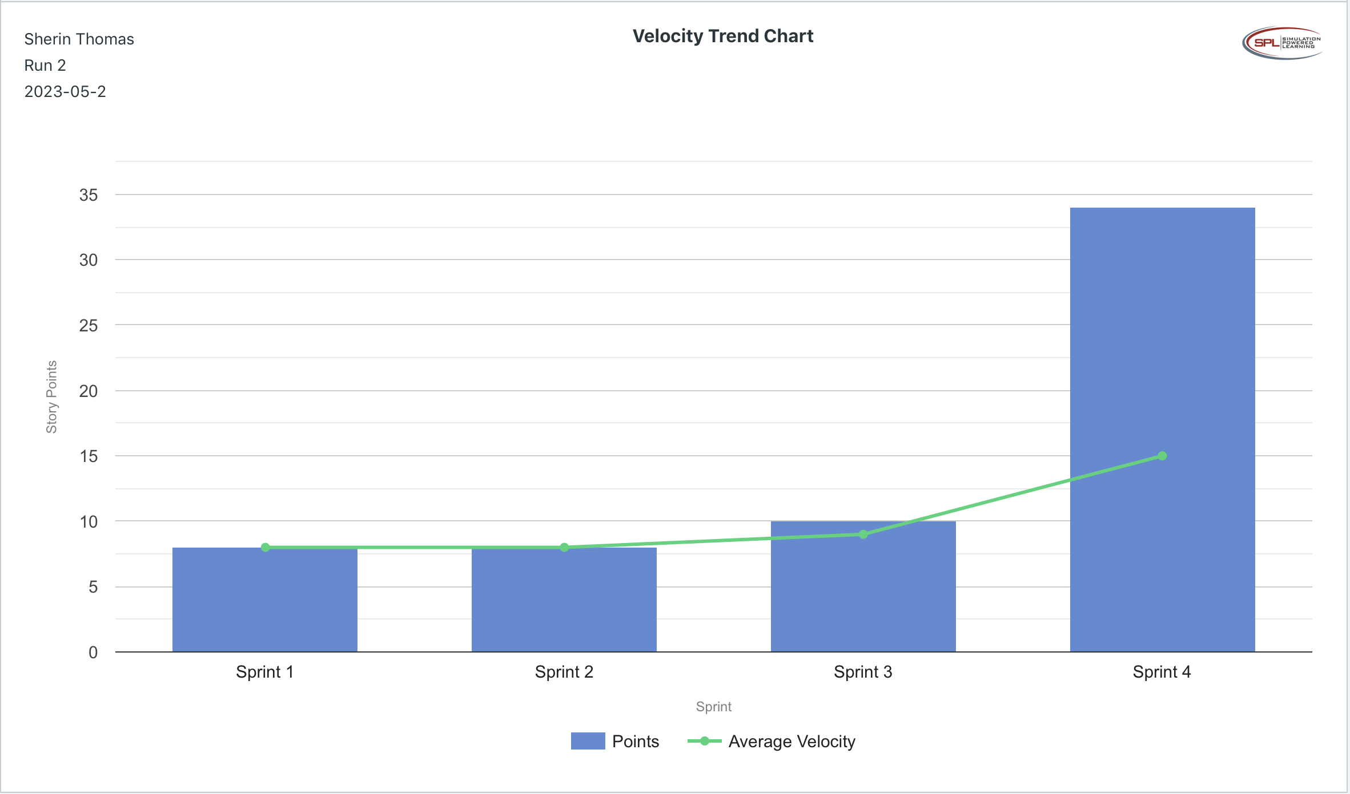

**Retrospective Meeting:**

How did you do in this sprint?

**Answer**

* We rate the sprint 5/5. This is because this sprint had the highest velocity compared to other sprints. Our team performed nearly 3x the velocity of previous sprints, and they completed all MVP user stories. We were astounded by the performance.

What problems, if any, did you encounter as you were executing the sprint?

**Answer**

* The only issue we noticed was developers continuing to miss scrum activities like Daily Stand Ups.

What changes, if any, are you are planning to make in the next sprint?

**Answer**

* Now that the MVP has been completed, we want to test the effects of other forms of training, particularly the Scrum Master training. We would assign the training to the individuals who have the greatest number of absences for scrum activities in hopes that a) they understand the importance of scrum activities b) they are more interested in the agile process since they are given training to advance in their career and possibly become scrum masters.
* We believe the simple calendar may have played a significant role in developers having a high velocity. Hence, calendars made forward will have reduced 1-on-1 sessions, and focus more on the necessary scum activities, team rewards, and individual rewards.

**Answer following questions based on this Sprint:**

What is the velocity (in story points) for the sprint?

**Answer**

* 34 story points

What is the average velocity, minimum velocity, and maximum velocity (in story points) for the project across all sprints that have been completed so far?

**Answer**

* Average: 15 story points
* Minimum: 9 story points
* Maximum: 34 story points

Did you deliver all required functionality needed for the MVP?  Explain your answer.

**Answer**

* Yes, we delivered all the required functionality needed for the MVP. We were surprised by the significant increase in velocity; we needed to complete over 30 story points in this Sprint to deliver the MVP, and our team was able to deliver 34 story points, meaning this sprint was a success in meeting our MVP milestone.

Did you deliver all the user stories in the product backlog? What were the three most significant items that effected your team’s performance?

**Answer**

* We were not able to deliver all the user stories in the product backlog.
* The three most significant items that effected our team’s performance is:
  + Keeping the calendar as simple as possible so more time is given to development rather than taking time away with sessions other than the required scrum activities.
  + Providing individual rewards made team members feel appreciated and recognized for their work. We received multiple notes from team members stating their gratefulness for monetary gift.
  + Utilizing the member workload chart to continuously assign developers to stories while running sprints aid in allocating resources better. We noticed that some developers were over their capacity while others had more hours available. Hence, if a user story allowed for more developers to work on it, we would add the developers who had available hours to that user story, so the workload is lessened among the developers assigned to it, preventing burnout/ overallocation.

**SimAgile Retrospective (20 points)**

The next three questions pertain to your thoughts about the performance of the BAAT project team across all four sprints after the project has completed.

1. How many story points did your BAAT project team deliver in your best execution of the simulation?

* Simulation 1: 65 story points
* Simulation 2: 60 story points
* The team delivered 65 story points in our best execution (simulation 1).

1. Describe three things that positively impacted the performance of the BAAT project team.

* Individual rewards increased team morale considering the multiple reports from developers saying they appreciated that we recognized their hard work.
* In execution 2, we provided Agile Bootcamp Team Training in the first week of the project to provide foundational agile knowledge to all team members. Even though training took away from time used to develop, we do believe that it helped decrease the number of absences for scrum activities in simulation 2 compared to simulation 1.
* Allocating developers to the PBI and stories in progress on a regular basis ensured that all available hours of developers were being utilized to complete user stories.

1. Describe three things that negatively impacted the performance of the BAAT project team.

* In both simulations, absenteeism by developers for scrum activities like the Daily Stand Up was prevalent.
* Many team members lacked knowledge of scrum principles and were not following agile. Farley wanted us to add user stories in the middle of the sprint, one developer did not want to work with others, and we received complaints about Daily Stand Ups. This shows that more trainings need to be done about the processes of agile as well emphasis on the importance of participating in scrum activities.
* We were notified that our team appears to have low morale and energy despite the rewards and sessions.

The final two questions pertain to your overall thoughts about the Agile Project Management.

1. What are the primary benefits of Scrum and the Scrum process? What type of projects are best suited for Scrum?

* The primary benefits of Scrum and the Scrum process are the ability to adapt to change, user involvement and feedback, and collaboration between all types of stakeholders.
* Scrum is best suited for projects with high levels of uncertainty i.e. changing requirements such as software development projects. Website, software program, mobile application are a few examples.

1. As a result of executing the SimAgile, discuss three lessons you learned related to how you will manage projects and people in the future.

* Providing individual rewards helps developers/ team members feel that their work and contributions are being appreciated
* Providing training at the beginning of a project will help set-up team members with the foundational knowledge necessary to work on a project based on the method used (Agile, Waterfall, etc.)
* Be ready to adapt to stakeholder feedback and present the appropriate material to the intended audience. In the SimAgile Week, Farley Gnu had pointed out “One other feedback I got from the business stakeholders, was that some of the demo stories were too technical and they did not quite understand the context. I would suggest that during our demos, we provide as much business context as possible.” Hence, we should be prepared to not only communicate with the people working on the project, but also present updates on the project in different contexts.